**WEBSITE FOR DEPARTMENT OF COMPUTER SCIENCE**

**Project Report Submitted**

**To**

**Gujarat University**

**In partial fulfilment of the requirements for**

**the award to the Degree of**

**5 YEAR INTEGRATED MASTER OF SCIENCE (COMPUTER SCIENCE)**

**SEMESTER – IV**

GUIDED BY: SUBMITTED BY:

**DR.BHUMIKA SHAH ANSH YADAV ( 40028 )**

**JANVI CHAUHAN ( 40003 )**



**DEPARTMENT OF COMPUTER SCIENCE**

**GUJARAT UNIVERSITY, AHMEDABAD**

**YEAR: 2022-23**

Department Of Computer Science

### Gujarat University



**Certificate**

**R**oll No : 36 Seat No : 40028

This is to certify that Mr. Ansh yadav Jagdhishbhai student of Fourth Semester of 5 years Integrated M.Sc (Computer Science) has duly completed his/her project titled

Website for Department of Computer Science for the semester ending in June 2023, towards partial fulfillment of degree of 5 years Integrated M.Sc (Computer Science).

Date of Submission Internal Project Guide

Course Coordinator

Head of Department

Department Of Computer Science

### Gujarat University



**Certificate**

**R**oll No : 03 Seat No : 40003

This is to certify that Mr. /Ms. Janvi Chauhan Harshad student of Fourth Semester of 5 years Integrated M.Sc (Computer Science) has duly completed his/her project titled Website for Department of Computer Science

for the semester ending in June 2023, towards partial fulfillment of degree of 5 years Integrated M.Sc (Computer Science).

Date of Submission Internal Project Guide

Course Coordinator

Head of Department

`

|  |  |
| --- | --- |
| **TITLE** | **DESCRIPTION** |
| Project Title | Website for Department of Computer Science |
| Aim of the Project | Provide detailed information of Department computer science |
| Project duration | 6 month |
| Team size | 2 Member |
| Tools used | Visul studio code, XAMPP Server, Github |
| Technologies used | Php, Html, Css, Tailwindcss, JavaScript, Mysql,  Jquery, Bootstrap-5 |
| Minimum software  And hardware  requirements | Any browser compatible with HTML, CSS,  JavaScript |
| Guide | Dr.Bhumika Shah |

**PROJECT PROFILE**

We would like to express our remarkable thanks of greatfulness to our project guide Dr. Bhumika Shah and to our Head of Department ( H.O.D ) Dr. Jyoti Pareek, who gave us the splendid opportunity to do this wonderful project.

This acknowledgement is a testament to the dedication, hard work, and technical expertise that went into building a remarkable dynamic platform. As the creator of this website, We are incredibly grateful for the opportunity to contribute to the enhancement of our department's online presence.The website serves as a valuable resource for students, faculty, staff, and visitors, providing them with easy access to essential information and fostering a sense of community within the department.

The design and layout of the website are visually appealing and intuitive, ensuring a seamless user experience. The thoughtful organization of content, including course details, syllabus, news, circular, information about events and department news, allows visitors to navigate the website effortlessly and find the information they need.

Moreover, the website showcases the accomplishments and achievements of our department. By highlighting faculty research, and alumni success stories, it reflects the collaborative and innovative spirit that defines our academic community. The website's regular updates and event listings promote engagement and keep stakeholders informed about the latest information within the department.

We would like to express our gratitude to all those who have supported us throughout this website-building journey. Thank you to the department leadership for entrusting us with this responsibility and providing guidance and feedback along the way.

We are grateful for the contributions of our peers and colleagues who provided valuable input, suggestions, and assistance during the development process.

**WITH THANKS TO ALL**

ANSH YADAV ( 40028 )

JANVI CHAUHAN ( 40003 )

**ACKNOWLEDGEMENT**

|  |  |  |
| --- | --- | --- |
| **S.R NO** | **TITLE** | **PAGE. NO** |
| 1 | **INTRODUCTION** | -- |
|  | * Objective | 4 |
|  | * Tools and Technologies | 5 |
| 2 | **SOFTWARE ANALYSIS** | -- |
|  | * Requirements | 6 |
|  | * Use Case Diagram | 7 |
|  | * Acitivity Diagram | 10 |
| 3 | **SOFTWARE DESIGN** | -- |
|  | * Class Diagram | 15 |
|  | * Data Dictionary | 16 |
|  | * Sequence diagram | 23 |
|  | * State Diagram | 25 |
| 4 | **SCREEN SHOTS** | 26 |
| 5 | **CONCLUSION** | 43 |
| 6 | **FUTURE WORK** | 44 |
| 7 | **REFERENCES** | 45 |

**TABLE OF CONTENT**

**ACKNOWLEDGEMENT**

Our objective is to create a dynamic and user-friendly platform that serves as a one-stop destination for all your computer science needs. Our website is dedicated to providing you with easy access to circulars, Question papers, course offerings, admission details, and feedback mechanisms. Additionally, our chatbot services are available to assist you in finding the information you need quickly and efficiently.

We understand the importance of staying up-to-date with the latest advancements in the field of computer science. That's why our website features circular, news, events, course pamphlets, syllabus, internal results a comprehensive online learning portal. You can access relevant syllabus information, explore research outcomes, and stay informed about the latest news and events.

We take pride in our commitment to academic excellence, and our website reflects that dedication. You'll find detailed information about our courses, faculty members, and the impressive awards our department has achieved. We strive to showcase the remarkable achievements of our students and faculty, highlighting their contributions to the field of computer science. Whether you're a student, faculty member, researcher, or a member of the wider community, we invite you to explore our website and engage in meaningful dialogue.

**INTRODUCTION**

* **OBJECTIVE**

Welcome to the official website of the Department of Computer Science! Our website is thoughtfully designed using a powerful set of tools and technologies to create an exceptional browsing experience tailored specifically for the field of computer science. Here's how we utilize these technologies:

* PHP: We employ PHP, a widely-used server-side scripting language, to develop dynamic web pages that facilitate efficient data processing. By leveraging PHP, we ensure interactive features and seamless functionality throughout our website.
* HTML: HTML forms the backbone of our web pages, providing a solid structure and content foundation. With HTML, we organize information and create a user-friendly layout, enabling easy navigation and accessibility for visitors.
* CSS: Cascading Style Sheets (CSS) play a crucial role in enhancing the visual appeal and aesthetics of our website. Through CSS, we apply custom styles, colors, and layouts to elements, ensuring a visually consistent and attractive user interface.
* Tailwind CSS: To streamline the design and development process, we utilize Tailwind CSS, a utility-first CSS framework. Tailwind CSS offers an extensive range of pre-built components and utilities, enabling us to create responsive and visually appealing web pages that align with modern design principles.
* JavaScript: JavaScript is employed to introduce interactivity and enhance functionality on our website. With JavaScript, we implement dynamic elements, handle user input, and create interactive features, thereby elevating the overall user experience
* JQuery: By leveraging the jQuery library, a popular JavaScript framework, we simplify HTML document traversing, event handling, and animation. jQuery enhances the functionality of our website, enabling smooth transitions, interactive elements, and streamlined code implementation.
* Bootstrap 5: We harness the power of Bootstrap 5, a robust front-end framework, to ensure responsive and mobile-friendly designs. By utilizing Bootstrap's pre-built components and responsive grid systems, we create visually appealing and accessible web pages that adapt seamlessly to different devices.

Through the strategic integration of these technologies, we have crafted a user-friendly and visually captivating website specifically tailored to the Department of Computer Science. Our primary goal is to provide an immersive browsing experience and easy access to information, empowering visitors to explore the exciting world of computer science conveniently and efficiently.

* **TOOLS AND TECHNOLOGIES**

Welcome to the administrative dashboard of the Department of Computer Science! As an authorized admin, you have access to a range of management functionalities that empower you to efficiently handle various aspects of our department's website. Here are the key features available to you:

* Login: Access the secure login system to enter the administrative dashboard and manage website content effectively.
* Manage Events: Take control of event management by adding, editing, and removing events from our department's calendar. Keep the community informed about upcoming conferences, workshops, seminars, and other relevant activities.
* Manage Newsletter: Stay connected with our audience by managing the department's newsletter. Create and distribute engaging newsletters that highlight recent developments, achievements, and important announcements.
* Manage Courses and Syllabus: Update and maintain the courses offered by the department. Keep the syllabus up to date, ensuring students have easy access to course materials, learning objectives, and other relevant information.
* Manage Feedback: Streamline the feedback collection process by managing and organizing feedback submissions from students, faculty, and other users. Use this valuable feedback to improve the department's programs and services.
* Manage Awards: Showcase the achievements of our faculty, students, and alumni by managing the awards section. Highlight their notable honour, scholarships, and recognitions, demonstrating the department's commitment to excellence.
* Manage Question papers: Provide a repository for research Question papers produced by the department's faculty and researchers. Manage and update the collection, allowing users to access the latest research findings and publications.
* Manage Results: Maintain a centralized system to manage and publish examination results of internal. Ensure transparency and accessibility by securely managing and displaying sessional results for students to access their result easily.
* Manage Circulars: Keep users informed about important announcements, policies, and updates by managing circulars. Easily edit and publish circulars to ensure timely and accurate communication.

With these powerful management features at your disposal, you can efficiently handle crucial aspects of our department's website. Your efforts contribute to maintaining an informative and engaging online platform for the Department of Computer Science.

* **REQUIREMENTS OF ADMIIN**

**SOFTWARE ANALYSIS**

**INTRODUCTION**

* **USE CASE DIAGRAM OF VISITOR**

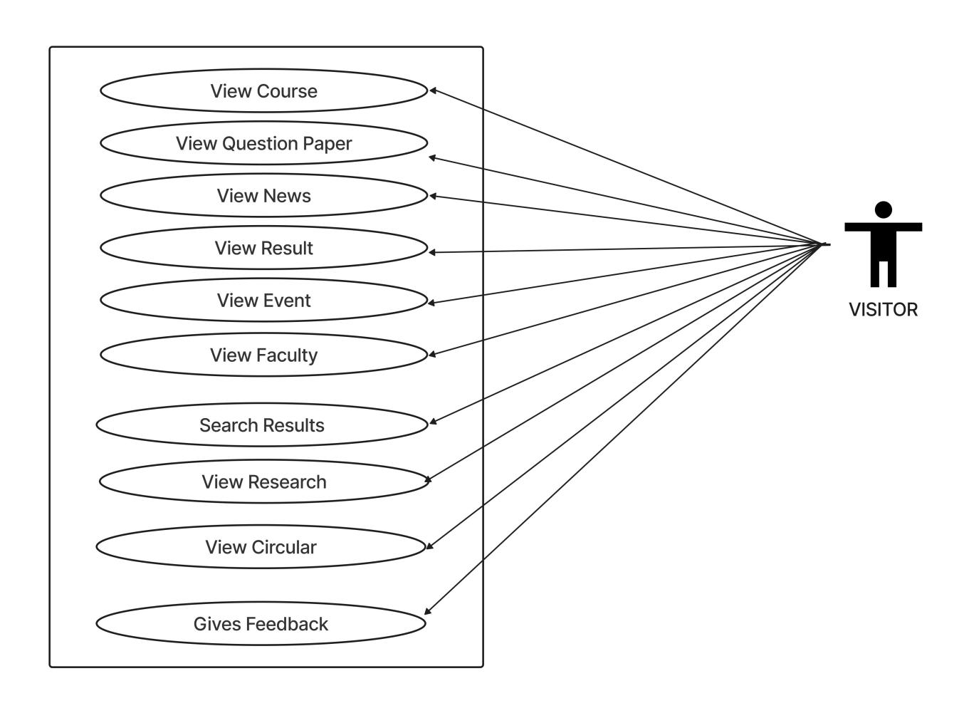

* **USE CASE DIAGRAM OF ADMIN**

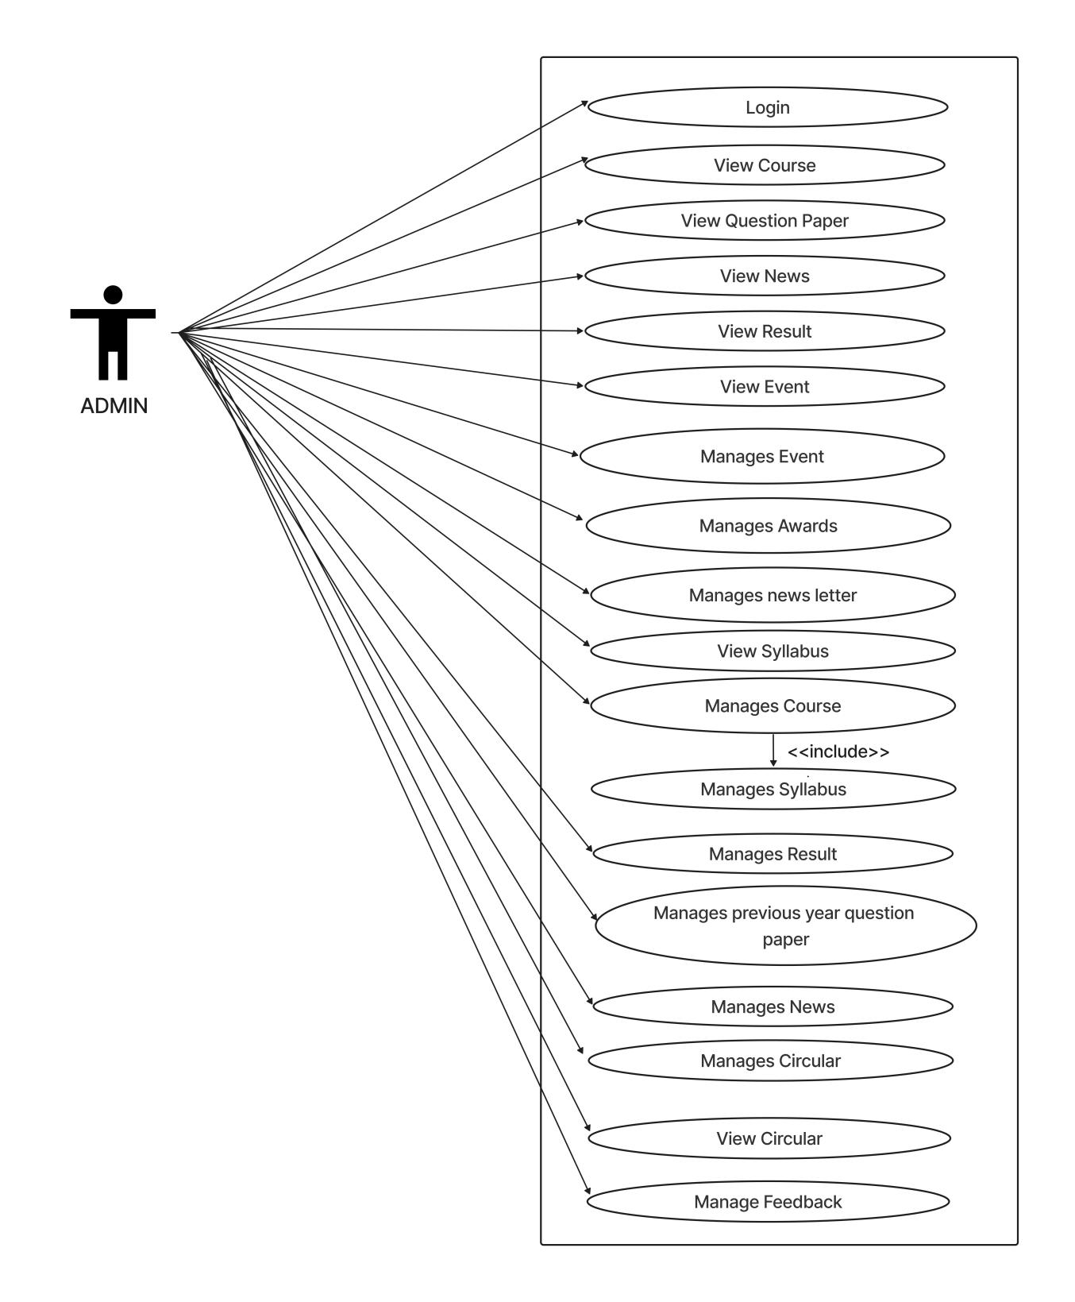

* **USE CASE DIAGRAM OF USERS**

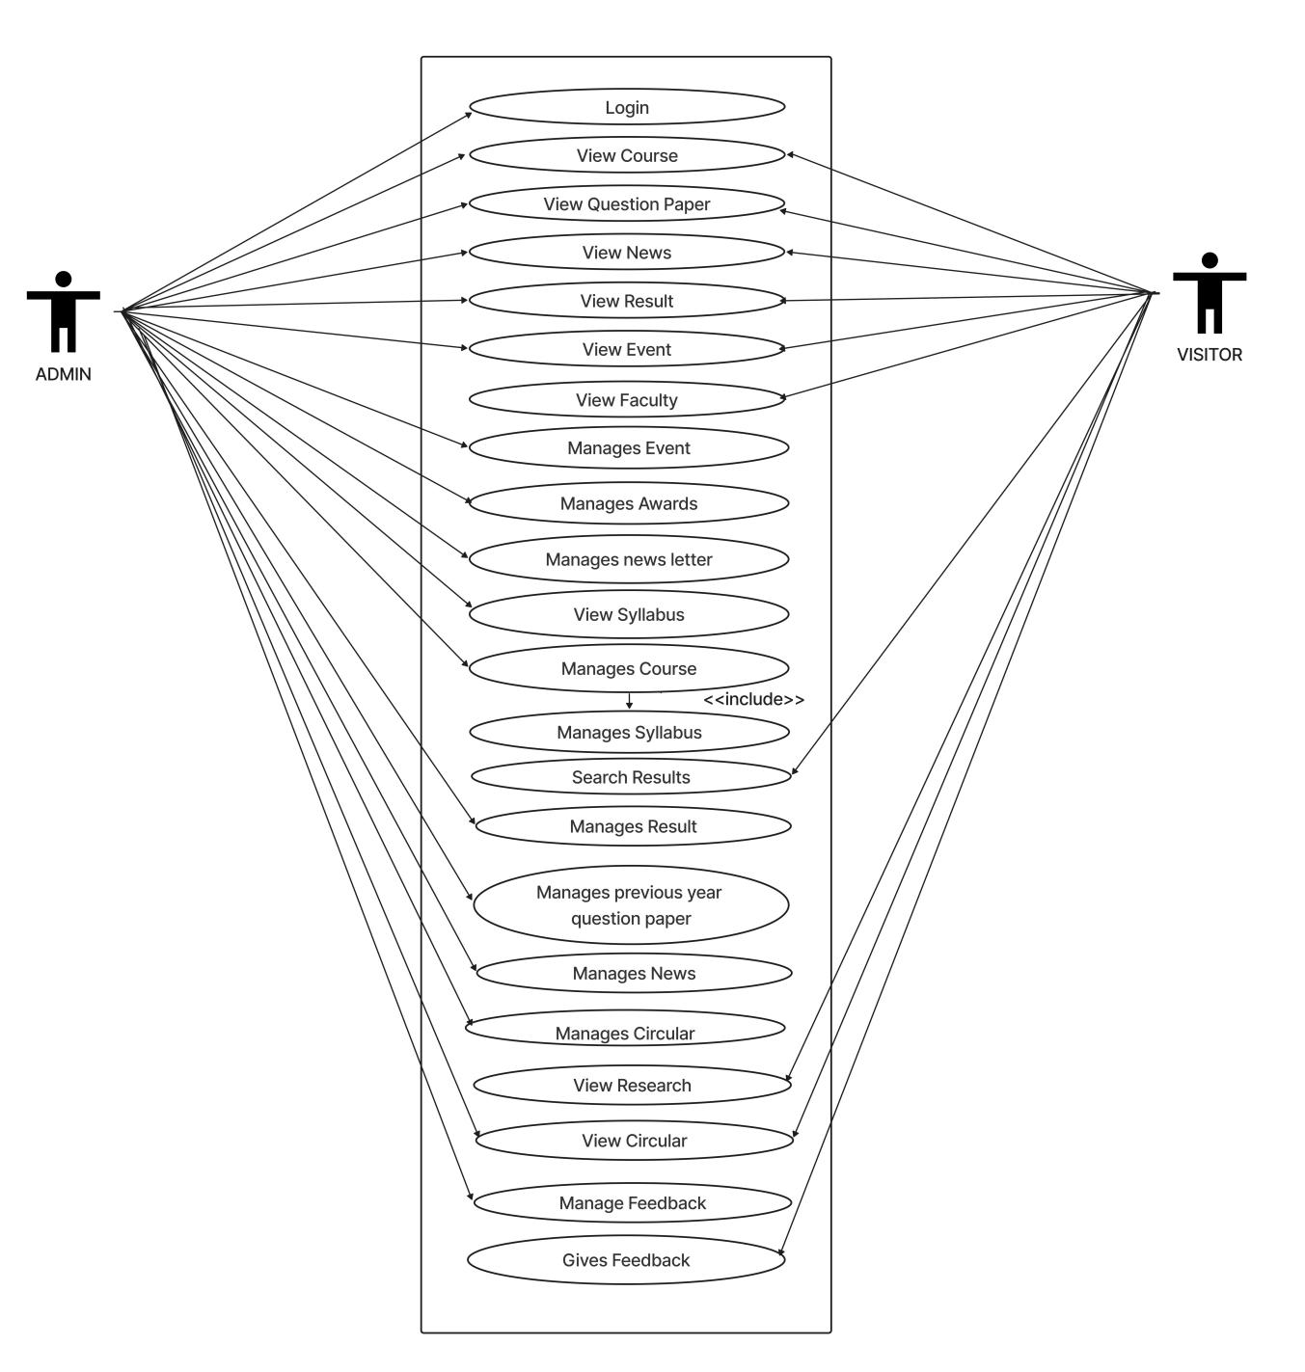

* **ACTIVITY DIAGRAM OF COURSES**

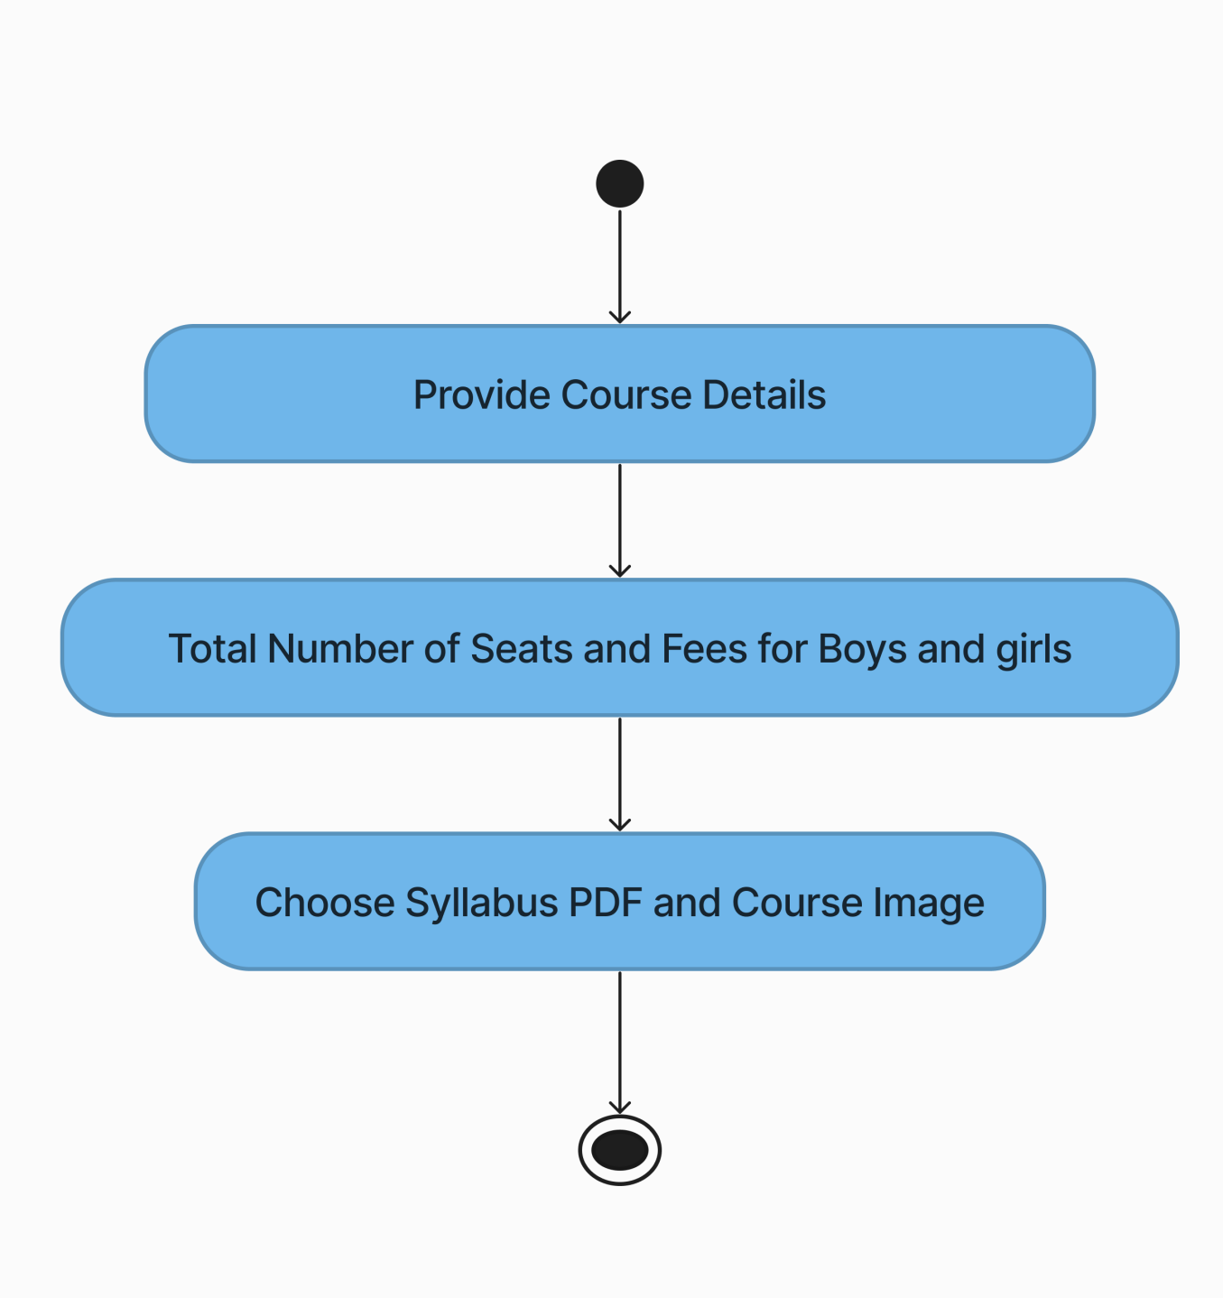

* **ACTIVITY DIAGRAM OF DOCUMENTS**

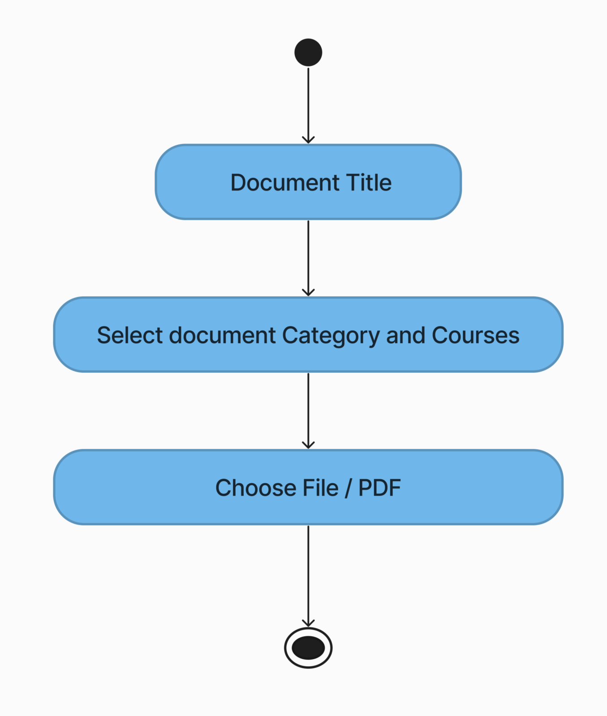

* **ACTIVITY DIAGRAM OF CHATBOT**

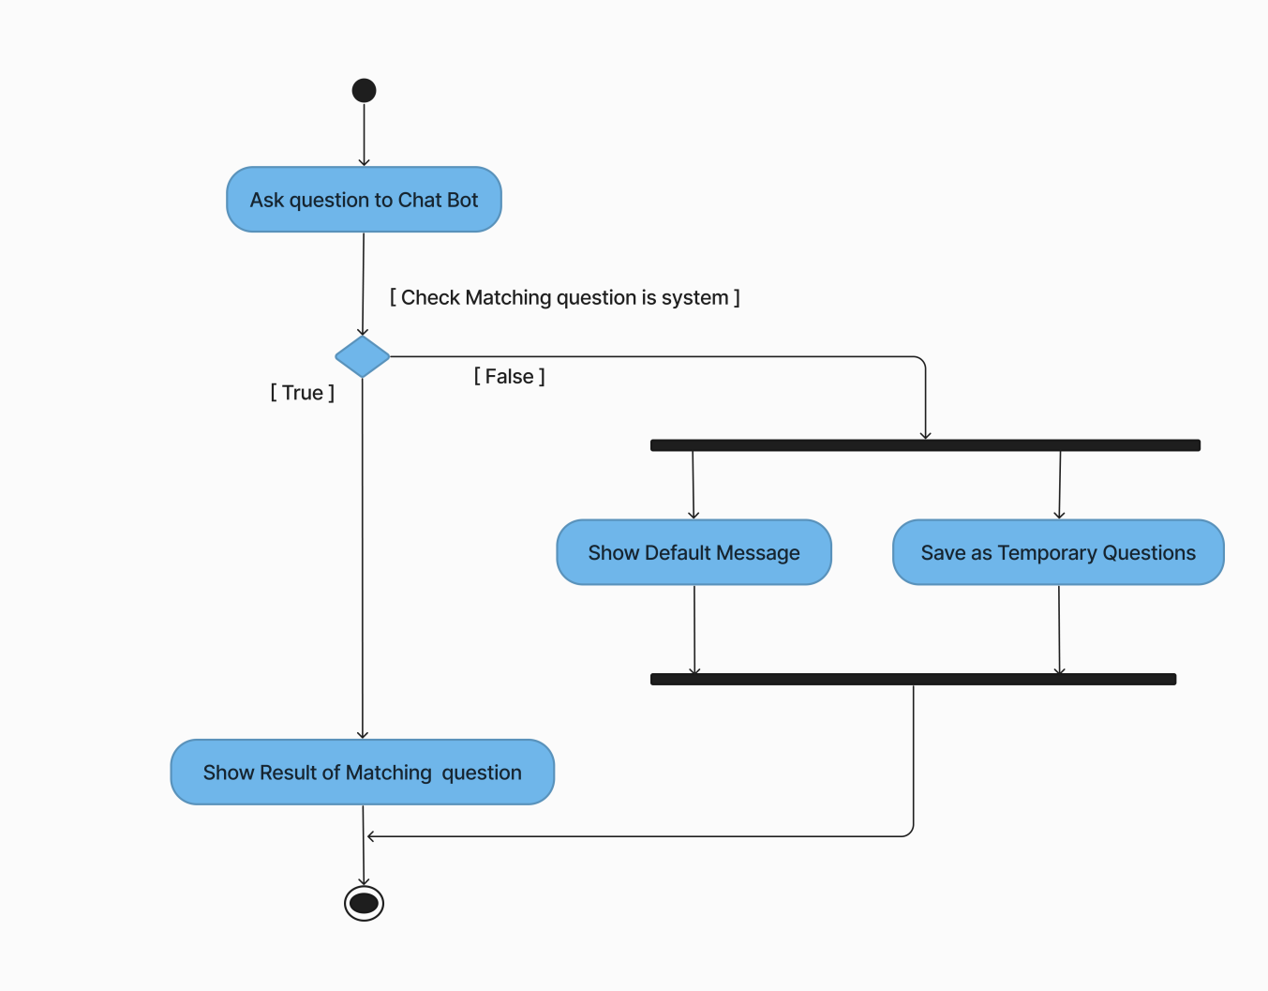

* **ACTIVITY DIAGRAM OF ADD QUESTIONS IN CHATBOT**

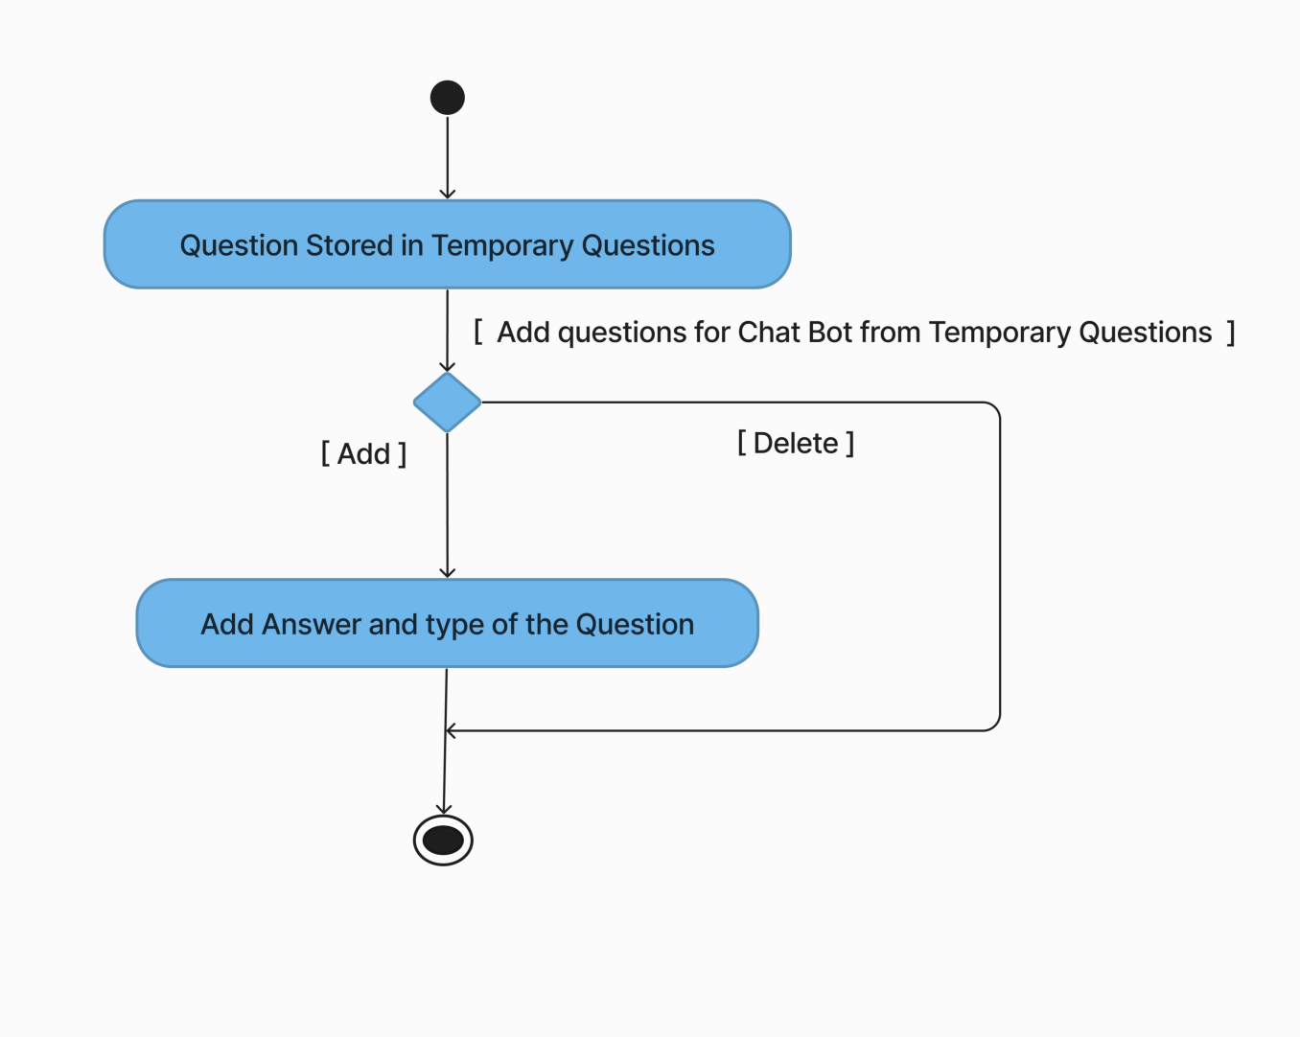

* **ACTIVITY DIAGRAM OF EVENTS CREATED**

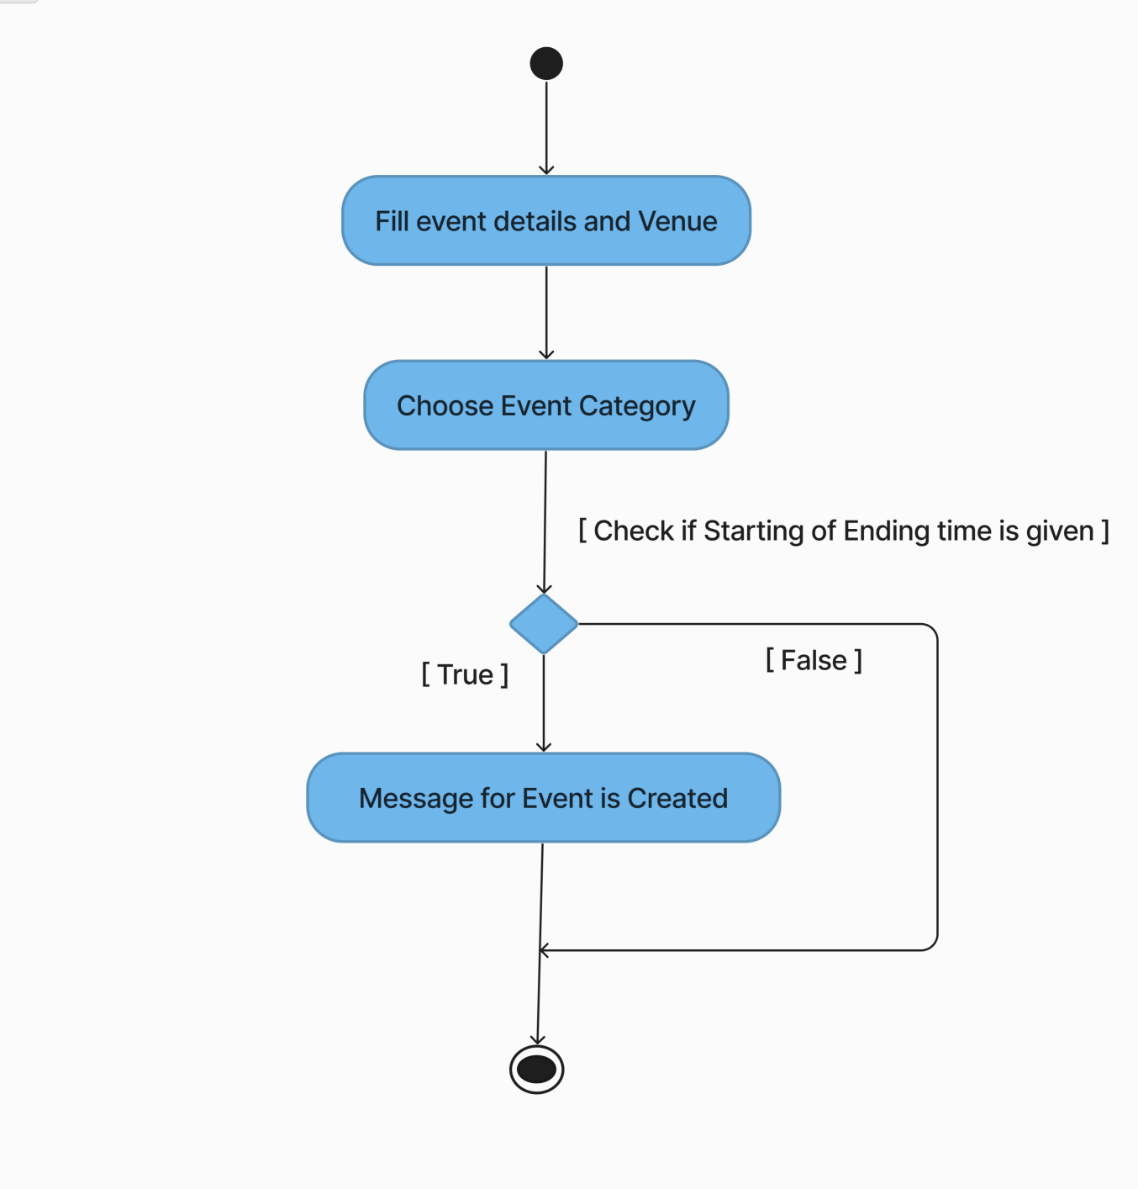

**SOFTWARE DESIGN**

* **CLASS DIAGRAM**

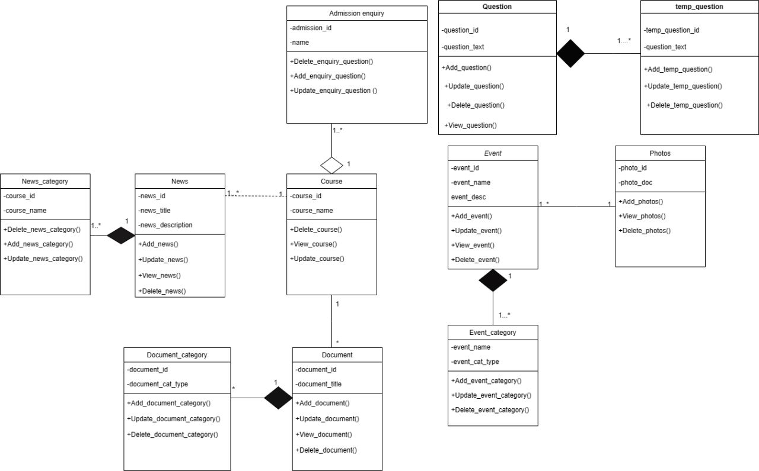

**DATA DICITONARY**

* **USER TABLE**

|  |  |  |  |  |  |
| --- | --- | --- | --- | --- | --- |
| **S.R NO** | **FIELD NAME** | **TYPE** | **SIZE** | **CONSTRAINTS** | **SAMPLE DATA** |
| 1 | user_id | INT | 5 | Primary key | 123 |
| 2 | user_name | VARCHAR | 10 |  | kapil |
| 4 | user_email | VARCHAR | 50 |  | kapil@gmail.com |
| 5 | user_password | VARCHAR | 25 |  | kapil123@45 |

* **ACHIEVEMENT TABLE**

|  |  |  |  |  |  |
| --- | --- | --- | --- | --- | --- |
| **S.R NO** | **FIELD NAME** | **TYPE** | **SIZE** | **CONSTRAINTS** | **SAMPLE DATA** |
| 1 | awd_id | INT | 3 | Primary key | 1 |
| 2 | awd_winner | VARCHAR | 255 |  | Viraj Nayar |
| 3 | awd_name | VARCHAR | 255 |  | nixi fellowships |
| 4 | awd_place | VARCHAR | 255 |  | For the most... |
| 5 | awd_time | DATE |  |  | 2014-02-12 |

* **EVENT CATEGORY TABLE**
* **EVENT TABLE**

|  |  |  |  |  |  |
| --- | --- | --- | --- | --- | --- |
| **S.R NO** | **FIELD NAME** | **TYPE** | **SIZE** | **CONSTRAINTS** | **SAMPLE DATA** |
| 1 | event_category_id | INT | 2 | Primary Key | 1 |
| 2 | event_category_type | VARCHAR | 30 |  | Technical |

* **EVENT TABLE**

|  |  |  |  |  |  |
| --- | --- | --- | --- | --- | --- |
| **S.R NO** | **FIELD NAME** | **TYPE** | **SIZE** | **CONSTRAINTS** | **SAMPLE DATA** |
| 1 | event_id | INT | 3 | Primary key | 1 |
| 2 | event_title | VARCHAR | 100 |  | Bhuvan Portal |
| 3 | event_description | TEXT |  |  | Lecture of Bhuvan portal |
| 4 | event_venue | VARCHAR | 100 |  | Senate hall, gujarat uni... |
| 5 | event_start | DATETIME |  |  | 08-01-2023  02:30:00 |
| 6 | event_end | DATETIME |  |  | 08-01-2023  02:30:00 |
| 8 | event_category_id | INT | 2 | Foregin key, Not Null | 11 |

* **ADMISSION ENQUIRY TABLE**

|  |  |  |  |  |  |
| --- | --- | --- | --- | --- | --- |
| **S.R NO** | **FIELD NAME** | **TYPE** | **SIZE** | **CONSTRAINTS** | **SAMPLE DATA** |
| 1 | photo_id | INT | 2 | Primary Key | 2 |
| 2 | photo_document | VARCHAR | 50 |  | ./document/event/event-1-2.webp |
| 3 | event_id | INT | 11 | Foreign Key, Not Null | 12 |

* **PHOTOS TABLE**

|  |  |  |  |  |  |
| --- | --- | --- | --- | --- | --- |
| **S.R NO** | **FIELD NAME** | **TYPE** | **SIZE** | **CONSTRAINTS** | **SAMPLE DATA** |
| 1 | admission_enquiry_id | INT | 2 | Primary key | 1 |
| 2 | course_id | INT | 11 | Foreign Key, Not Null | 2 |
| 3 | name | VARCHAR | 100 |  | Alex |
| 4 | email | VARCHAR | 255 |  | alex05@gmail.com |
| 5 | phone | VARCHAR | 15 |  | 9343212331 |
| 6 | subject | VARCHAR | 255 |  | What the data to be.. |
| 7 | message | TEXT | 255 |  | Hello, I am... |

* **COURSE TABLE**
* **DOCUMENT CATEGORY TABLE**

|  |  |  |  |  |  |
| --- | --- | --- | --- | --- | --- |
| 1. **R NO** | **FIELD NAME** | **TYPE** | **SIZE** | **CONSTRAINTS** | **SAMPLE DATA** |
| 1 | document_category_id | INT | 2 | Primary Key | 1 |
| 2 | document_category_type | VARCHAR | 30 |  | Result |

|  |  |  |  |  |  |
| --- | --- | --- | --- | --- | --- |
| **S.R NO** | **FIELD NAME** | **TYPE** | **SIZE** | **CONSTRAINTS** | **SAMPLE DATA** |
| 1 | course_id | INT | 2 | Primary key | 1 |
| 2 | course_name | VARCHAR | 255 |  | integrated msc(cs) |
| 3 | course_duration | TINYINT | 1 |  | 5 |
| 4 | course_details | TEXT | 255 |  | 5 year integrated msc... |
| 5 | course_document | TEXT | 255 |  | ./document/course/mca.pdf |
| 6 | course_image | TEXT | 255 |  | ./document/course/photos/mca.webp |
| 7 | seat_number | INT | 11 |  | 120 |
| 8 | boys_fees | VARCHAR | 11 |  | 12,000 |
| 9 | girls_fees | VARCHAR | 11 |  | 12,000 |
| 10 | brouchers | VARCHAR | 100 |  | ./pgdcsa.php |

* **NEWS TABLE**

|  |  |  |  |  |  |
| --- | --- | --- | --- | --- | --- |
| **S.R NO** | **FIELD NAME** | **TYPE** | **SIZE** | **CONSTRAINTS** | **SAMPLE DATA** |
| 1 | news_id | INT | 5 | Primary Key | 3 |
| 2 | news_title | VARCHAR | 50 |  | xyz |
| 3 | news_description | TEXT | 255 |  | abc... |
| 4 | expire_date | DATE |  |  | 2022-05-23 |
| 5 | news_cat_id | INT | 2 | Foregin key, Not Null | 4 |

|  |  |  |  |  |  |
| --- | --- | --- | --- | --- | --- |
| **S.R NO** | **FIELD NAME** | **TYPE** | **SIZE** | **CONSTRAINTS** | **SAMPLE DATA** |
| 1 | document_id | INT | 2 | Primary Key | 2 |
| 2 | document_title | TEXT | 255 |  | Mca-2, Sessional-1 |
| 3 | doucment_location | VARCHAR | 50 |  | ./document/event/result-1-2.pdf |
| 4 | course_id | INT | 11 | Foreign Key, Not Null | 5 |
| 5 | doucument_category_id | INT | 2 | Foreign Key, Not Null | 1 |

* **DOCUMENT TABLE**
* **FEEDBACK TABLE**

|  |  |  |  |  |  |
| --- | --- | --- | --- | --- | --- |
| **S.R NO** | **FIELD NAME** | **TYPE** | **SIZE** | **CONSTRAINTS** | **SAMPLE DATA** |
| 1 | feedback_id | INT | 11 | Primary key | 1 |
| 2 | name | VARCHAR | 100 |  | Alex |
| 3 | email | VARCHAR | 255 |  | alex05@gmail.com |
| 4 | phone | VARCHAR | 15 |  | 9343212331 |
| 5 | message | TEXT | 255 |  | I want to... |

|  |  |  |  |  |  |
| --- | --- | --- | --- | --- | --- |
| **S.R NO** | **FIELD NAME** | **TYPE** | **SIZE** | **CONSTRAINTS** | **SAMPLE DATA** |
| 1 | news_category_id | INT | 2 | Primary Key | 4 |
| 2 | news_category_type | VARCHAR | 50 |  | Workshops |

* **NEWS CATEGORY TABLE**
* **ACTIVITY DIAGRAM**
* **QUESTION TABLE**
* **TEMPORARY QUESTION TABLE**

|  |  |  |  |  |  |
| --- | --- | --- | --- | --- | --- |
| **S.R NO** | **FIELD NAME** | **TYPE** | **SIZE** | **CONSTRAINTS** | **SAMPLE DATA** |
| 1 | question_id | INT | 11 | Primary Key | 1 |
| 2 | question | TEXT | 255 |  | admission |
| 3 | answer | TEXT | 255 |  | You can access… |
| 4 | type | VARCHAR | 35 |  | TEXT |

|  |  |  |  |  |  |
| --- | --- | --- | --- | --- | --- |
| **S.R NO** | **FIELD NAME** | **TYPE** | **SIZE** | **CONSTRAINTS** | **SAMPLE DATA** |
| 1 | question_id | INT | 11 | Primary Key | 1 |
| 2 | question | TEXT | 255 |  | Courses |
| 3 | type | VARCHAR | 35 |  | TEXT |

* **SEQUENCE DIAGRAM OF CHATBOT**

**DIAGRAMS**

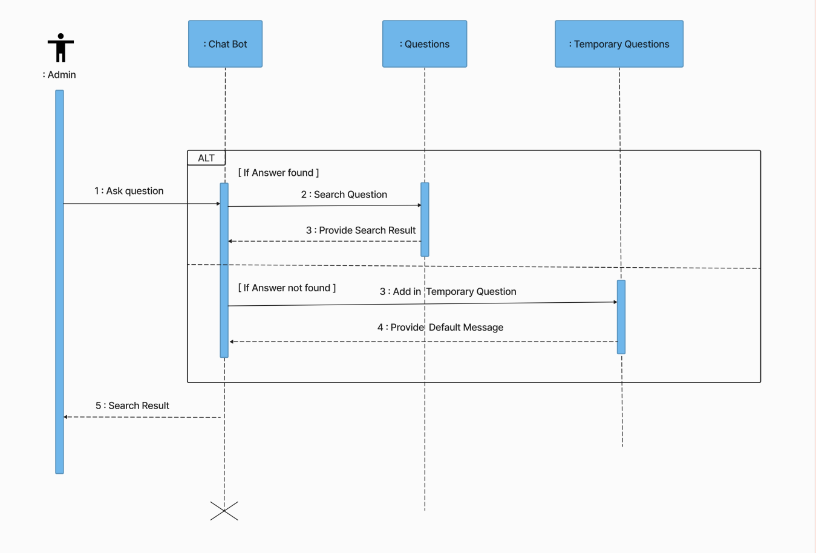

* **SEQUENCE DIAGRAM OF DOCUMENTS**

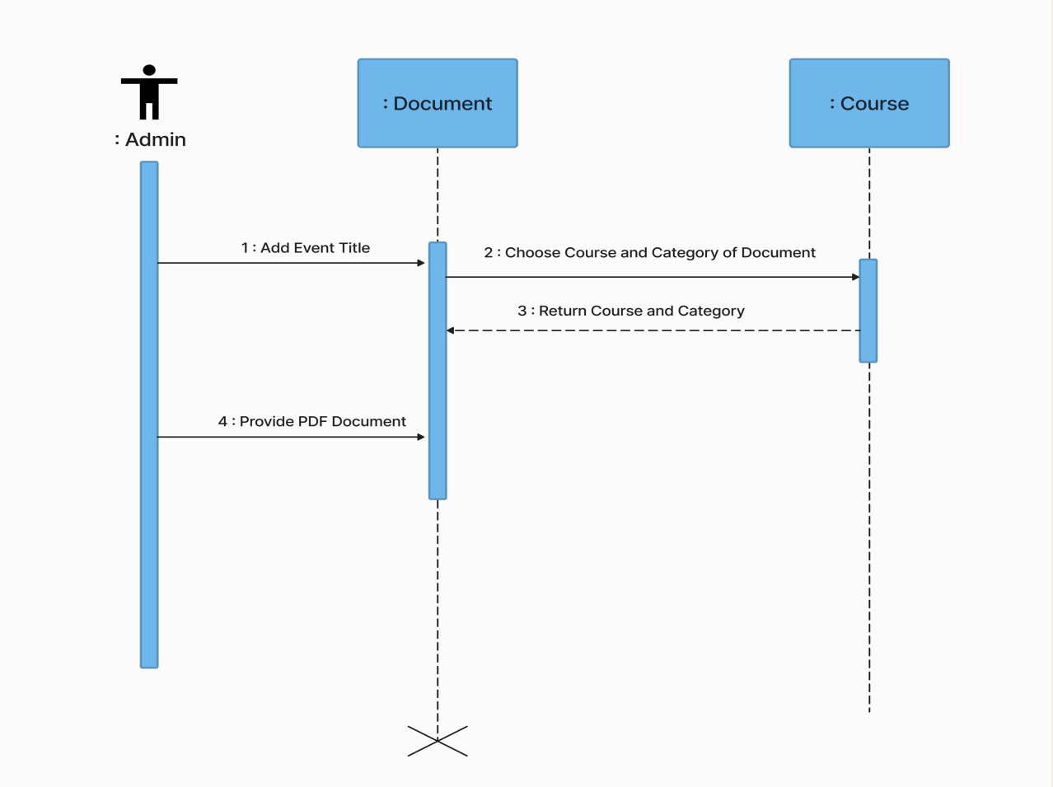

* **SEQUENCE DIAGRAM OF NEWS**

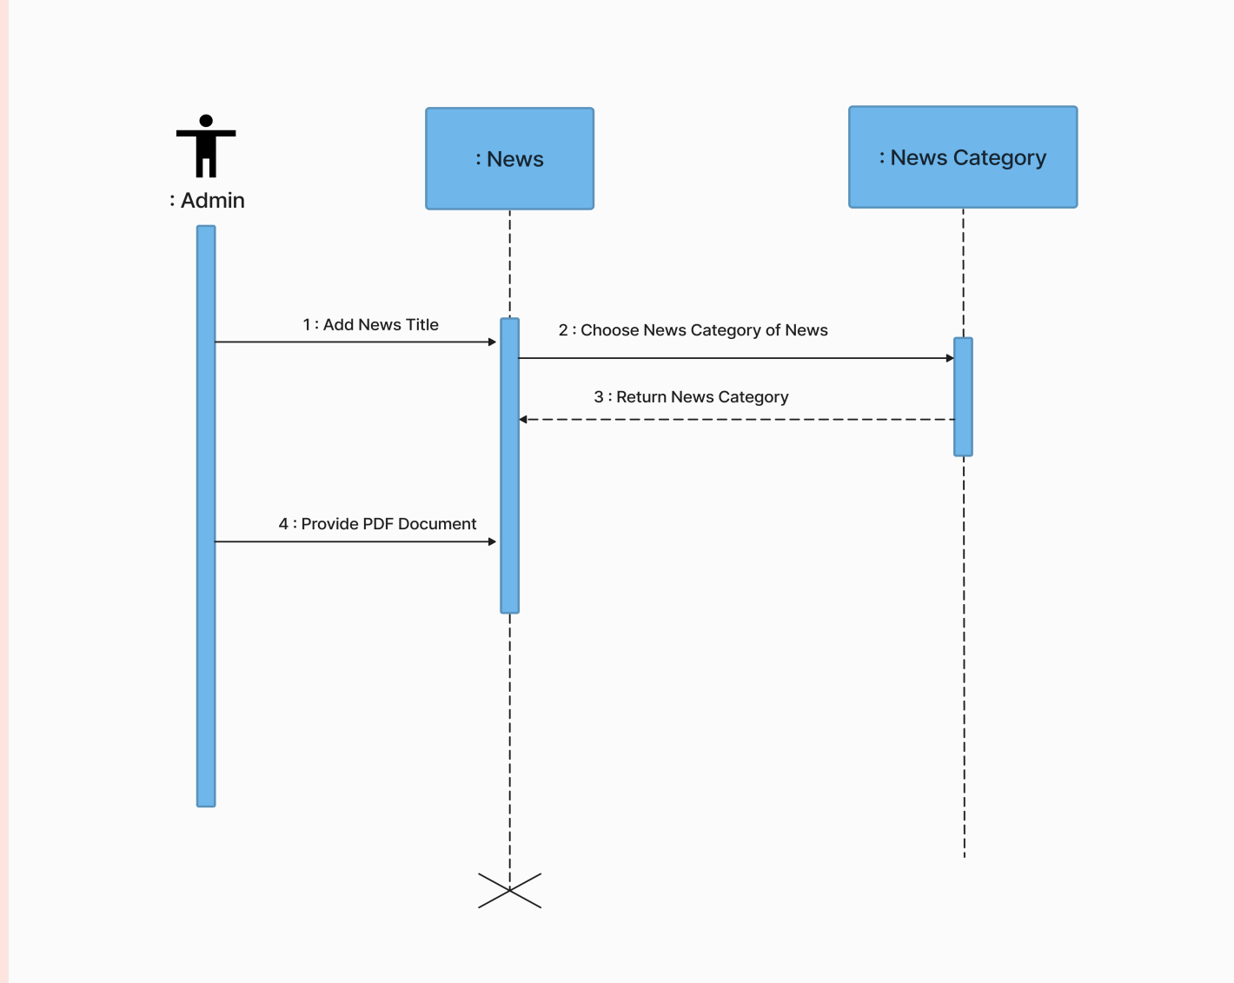

* **STATE DIAGRAM OF CHATBOT**

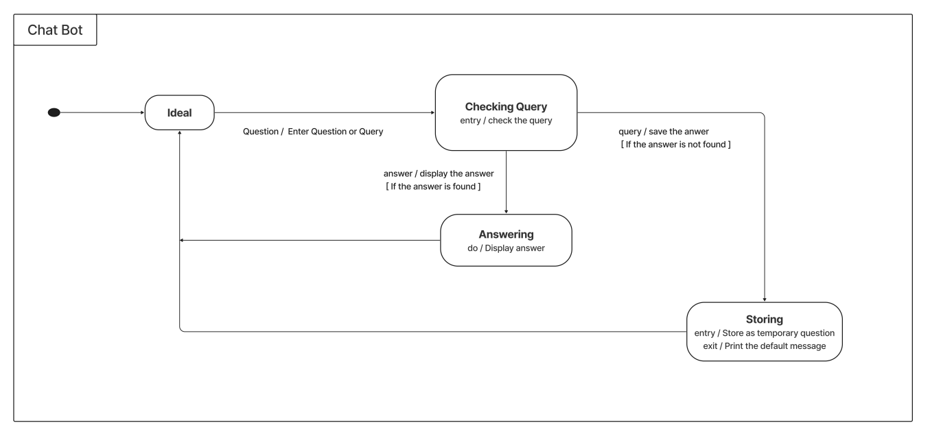

* **STATE DIAGRAM OF COURSE**

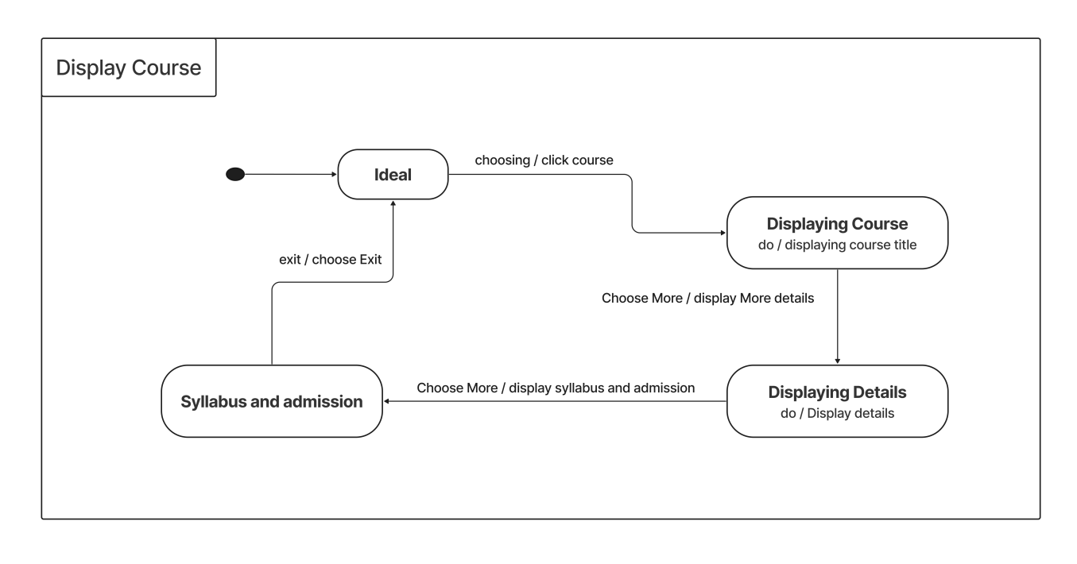

**SCREENSHOTS**

* **NAVBAR**



* **FOOTER**

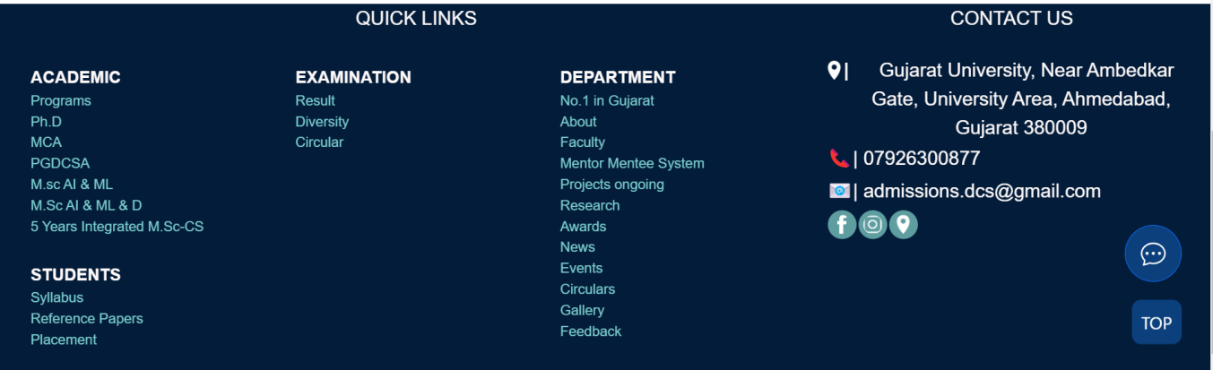

* **HOME**

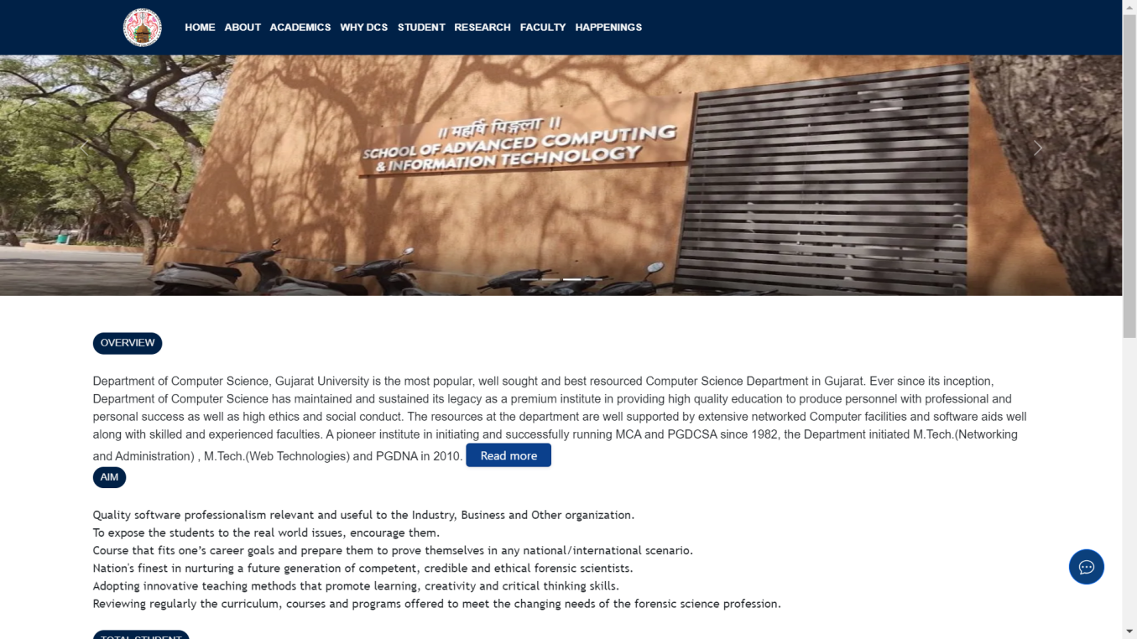

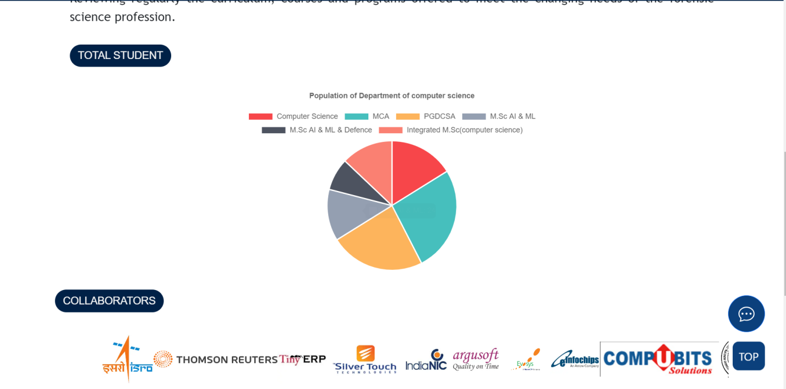

* **E-PG PATHSHALA**

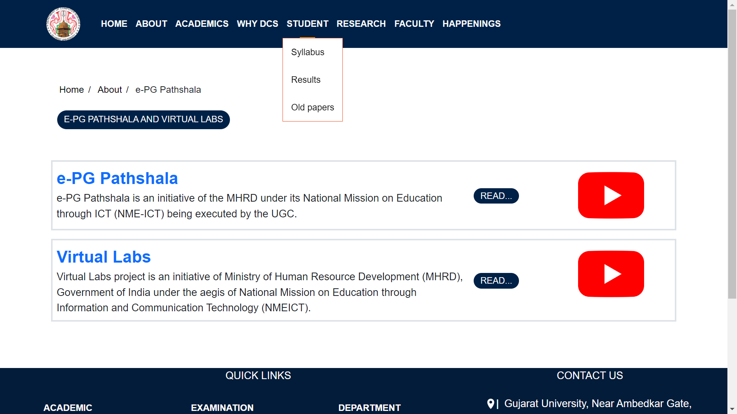

* **FEEDBACK**

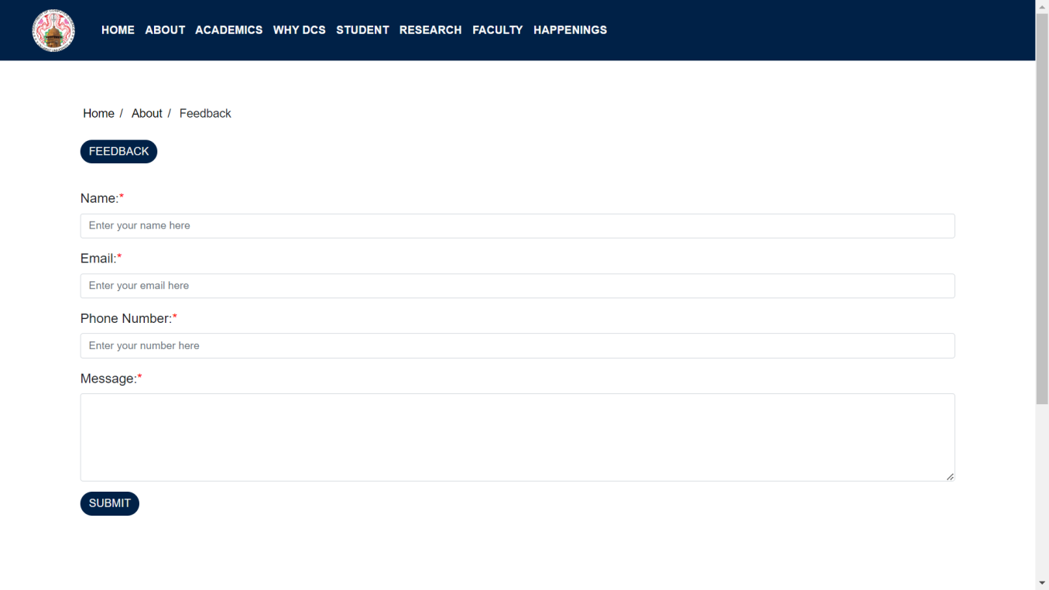

* **ACADEMICS**

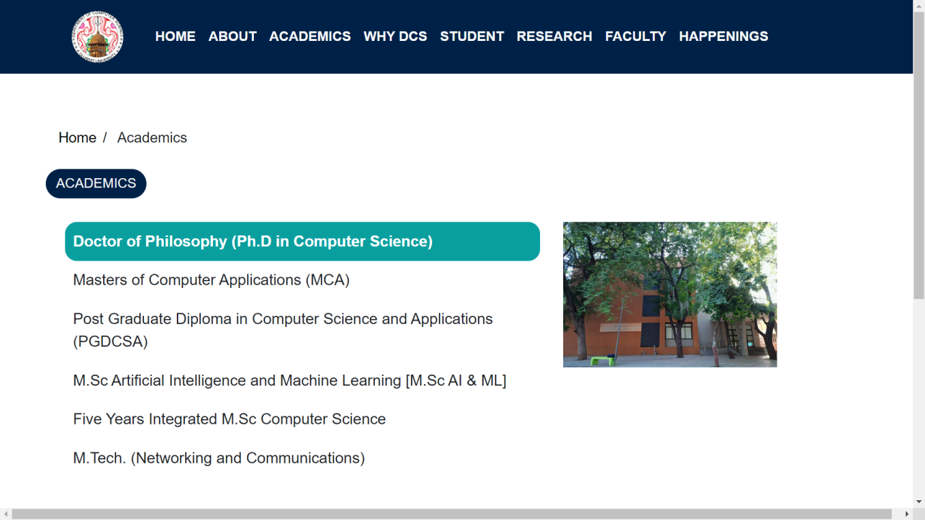

* **COURSES**

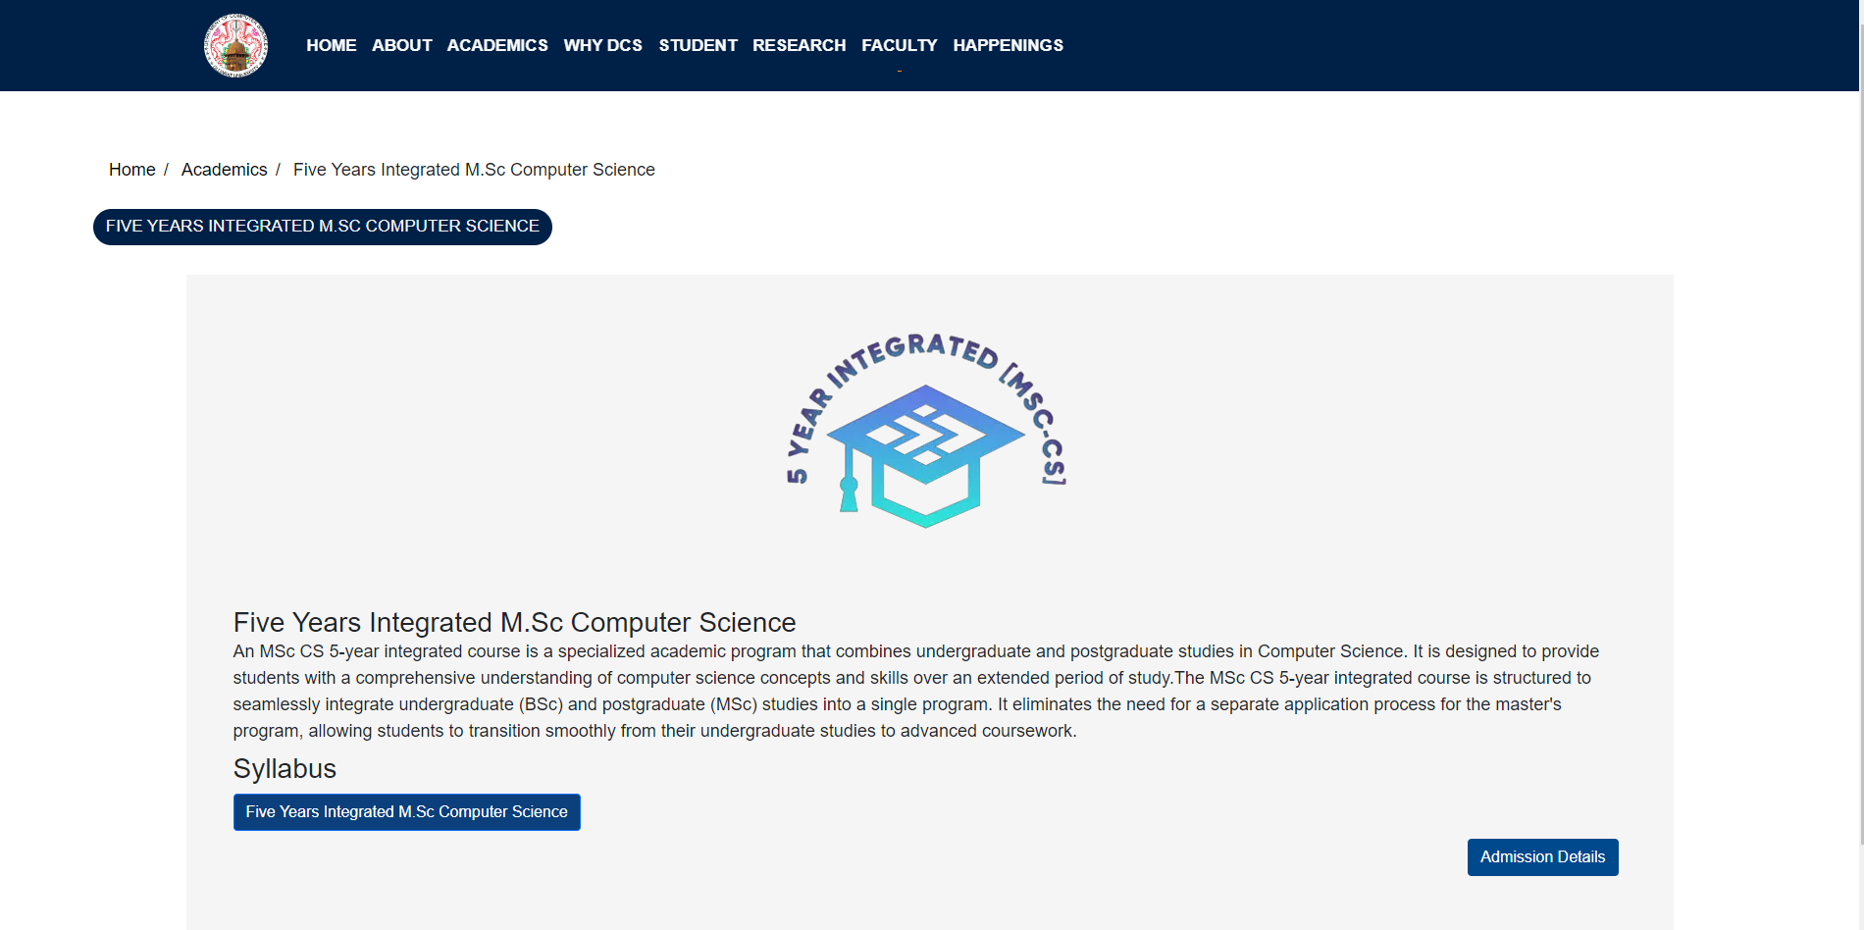

* **ADMISSION PAPLETS**

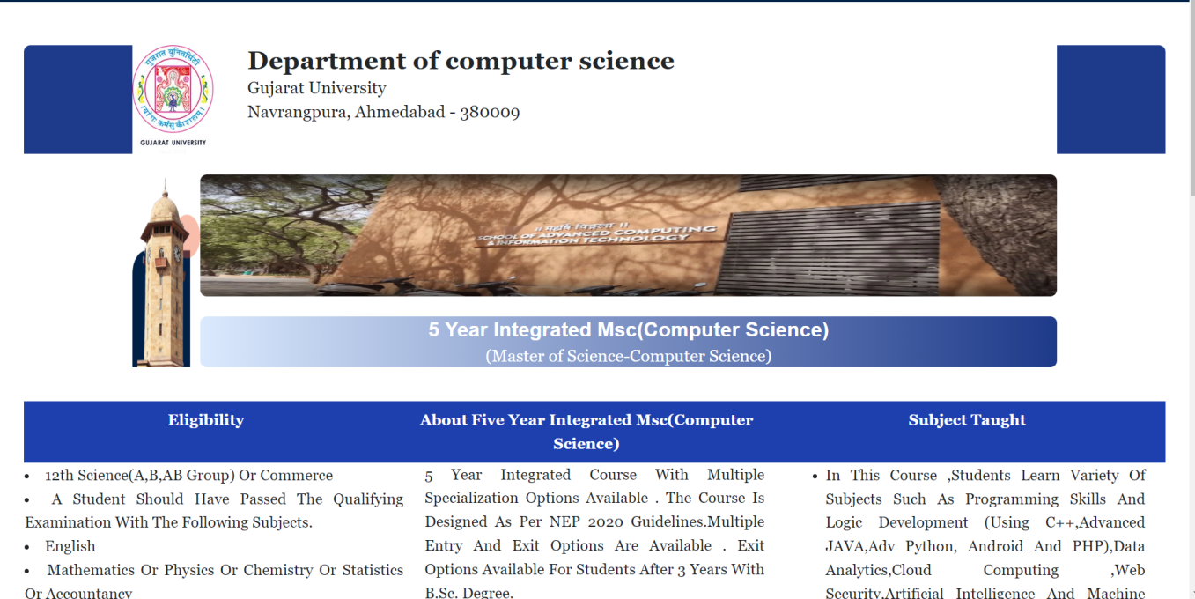

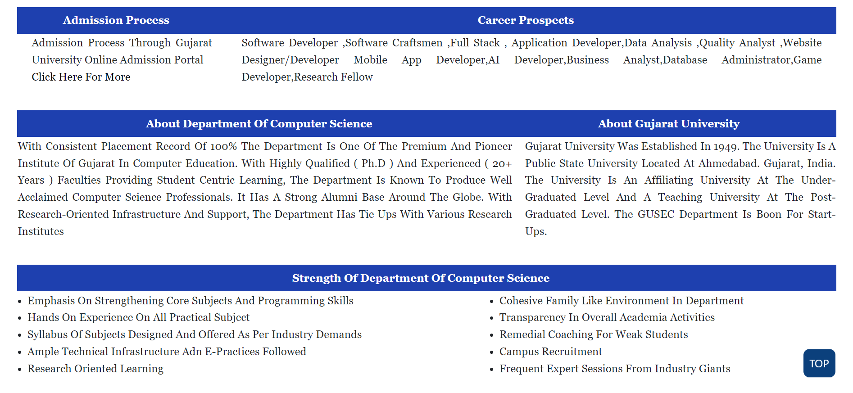

* **SYLLABUS**

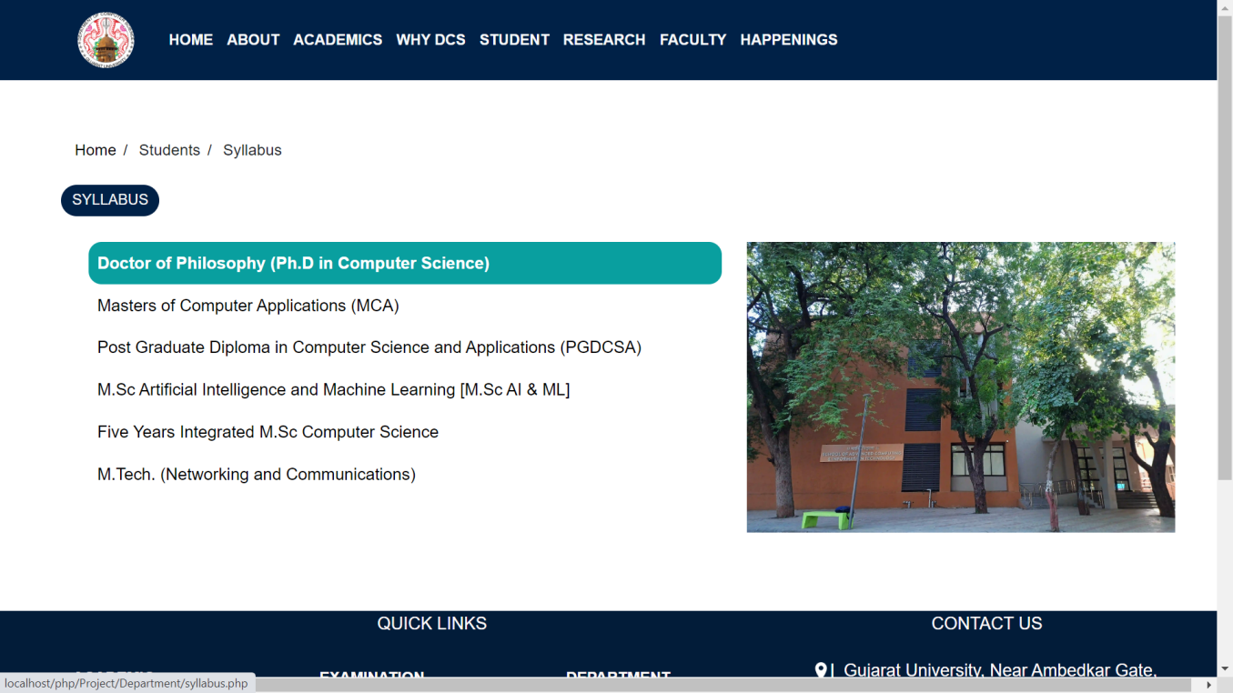

* **RESULTS**

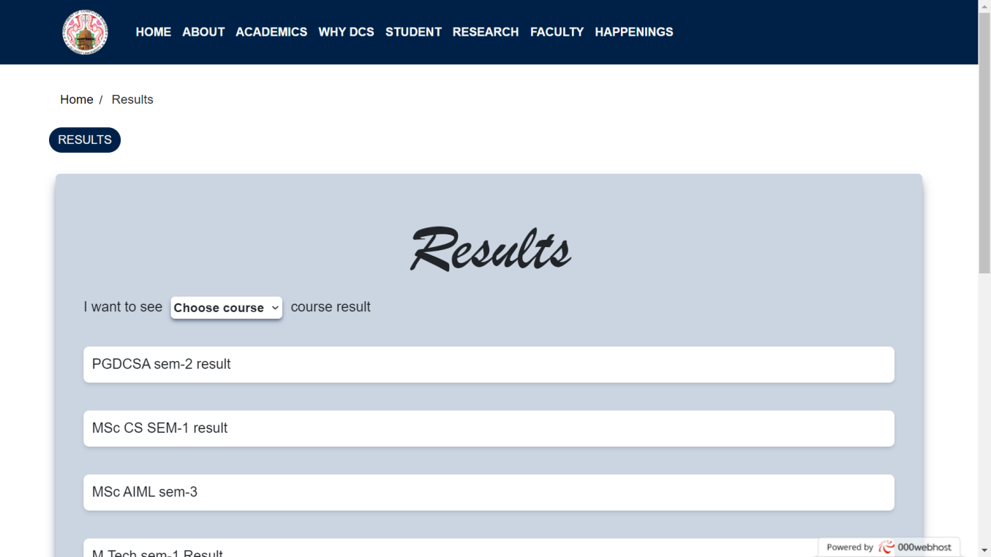

* **QUESTION PAPERS**

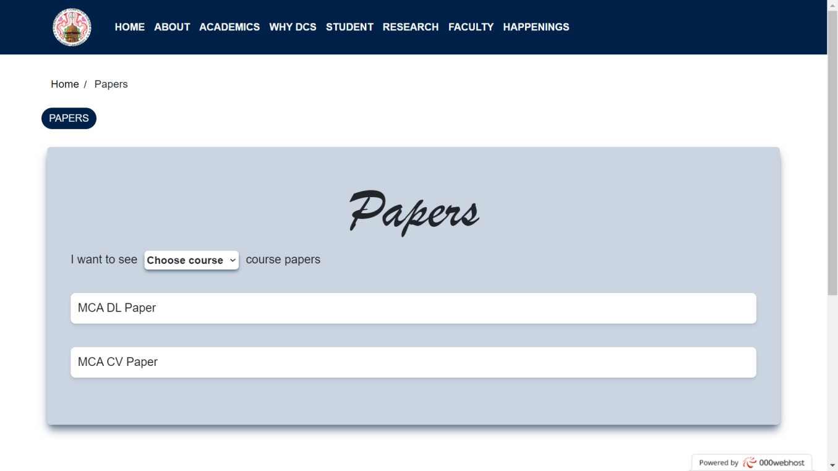

* **AWARDS**
* **AWARDS**

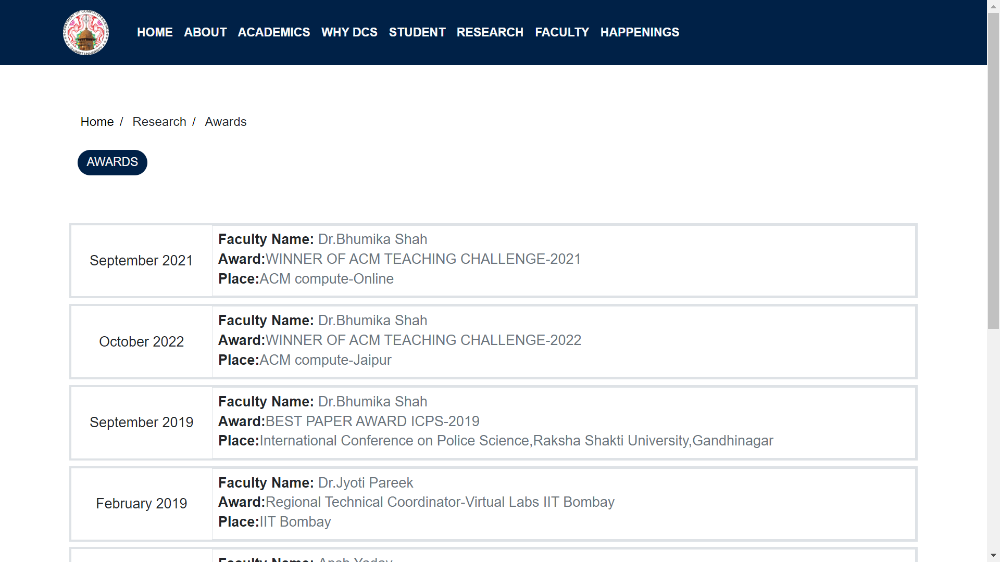

* **NEWS**

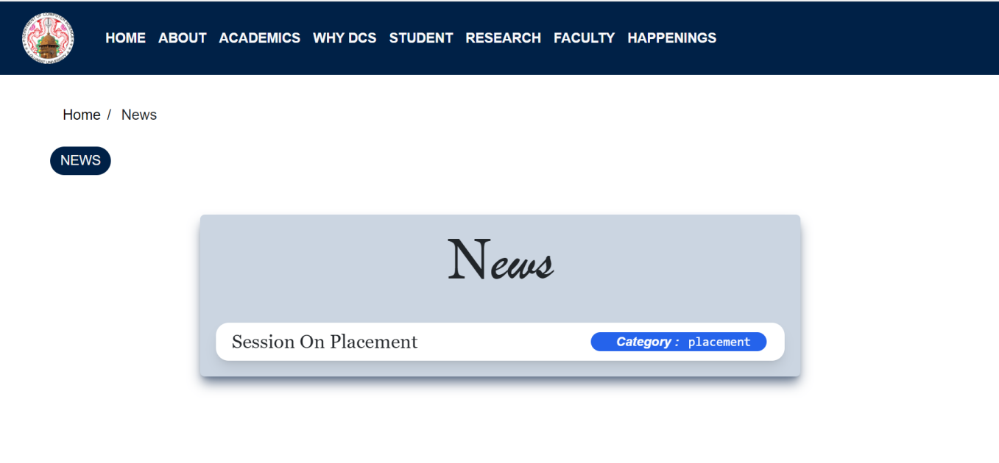

* **NEWS DETAIL**

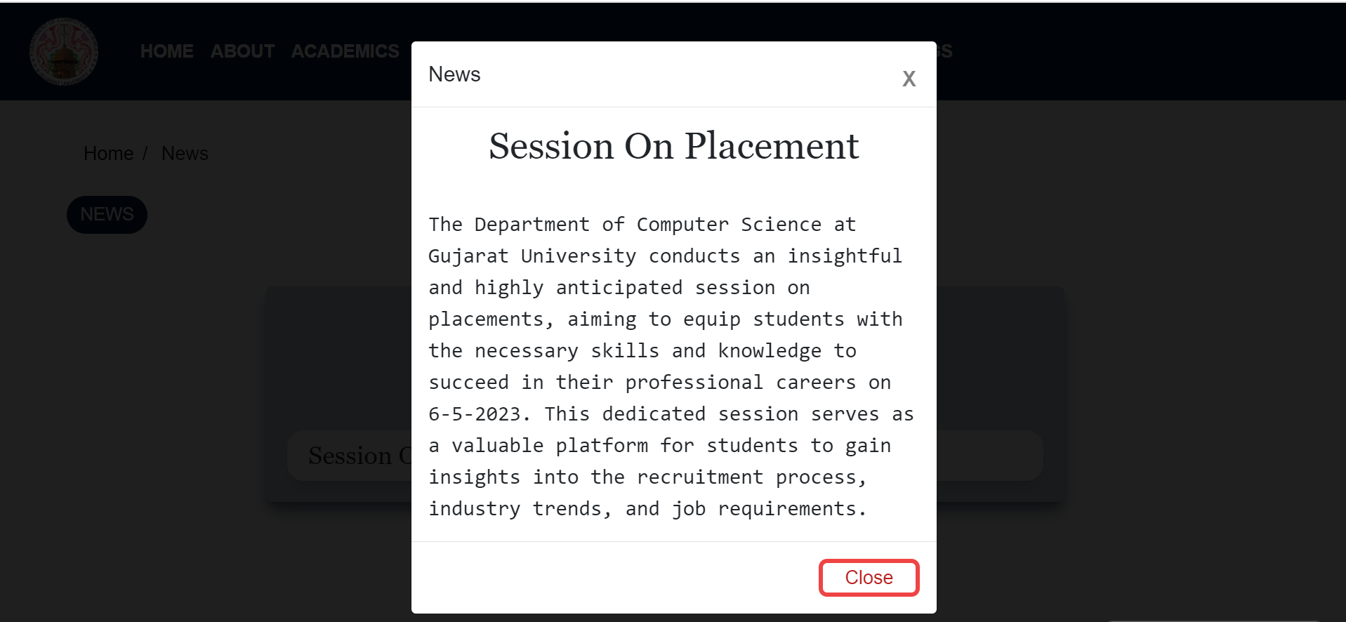

* **EVENTS**

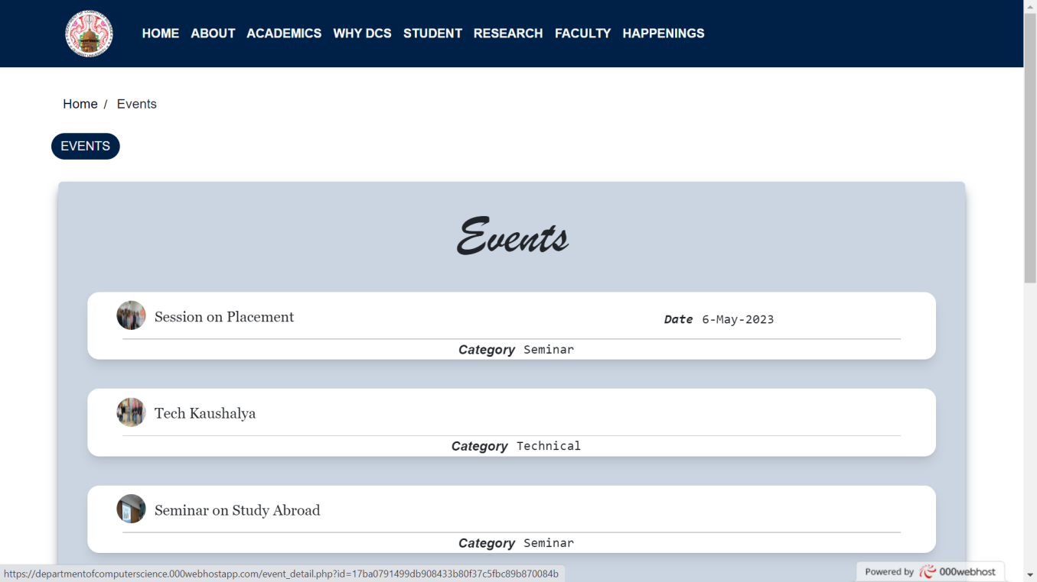

* **EVENT DETAILS**

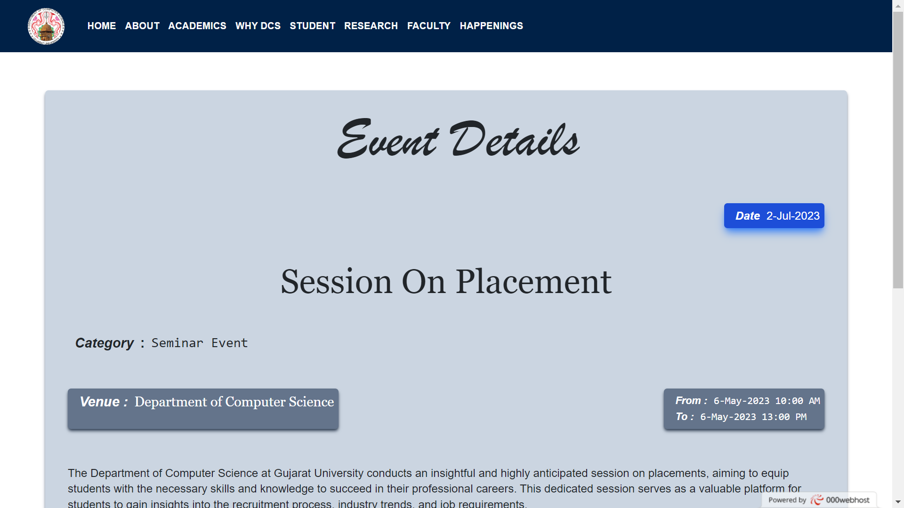

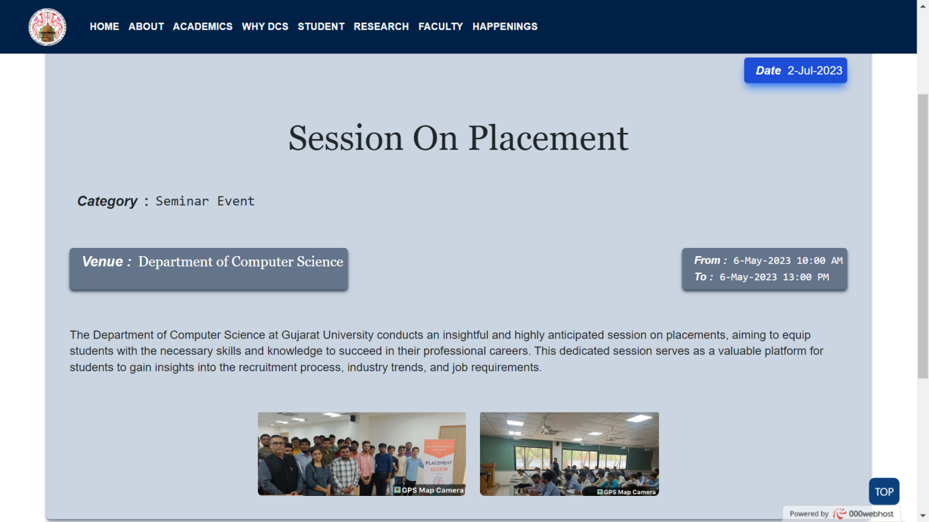

* **CIRCULARS**

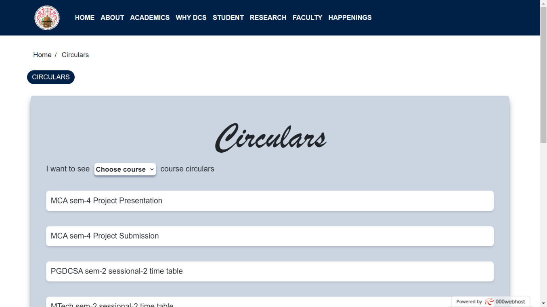

* **GALLERY**

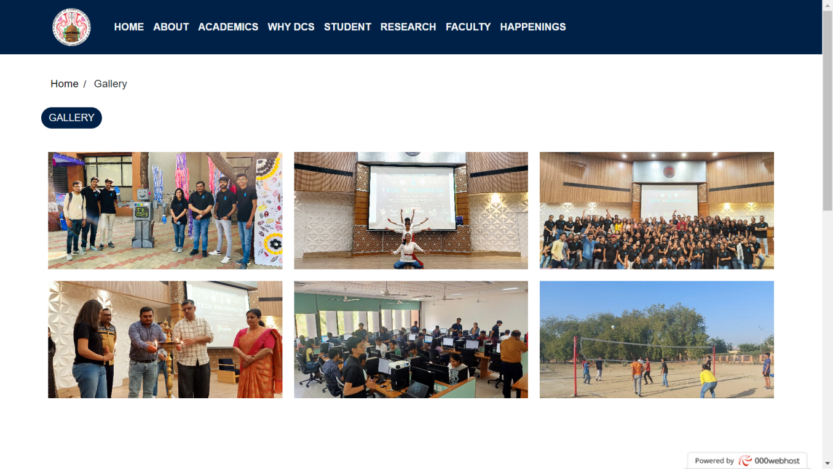

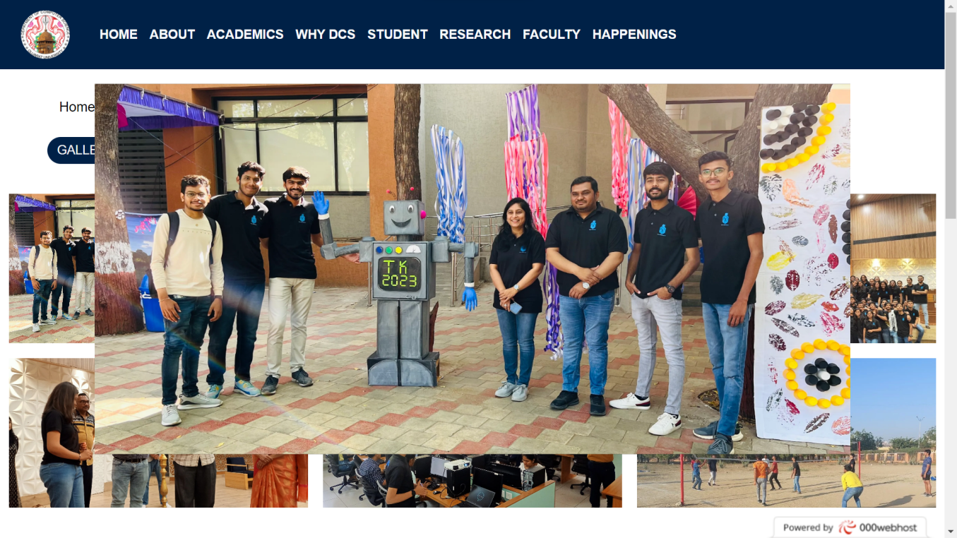

* **ADMIN HOME PAGE**

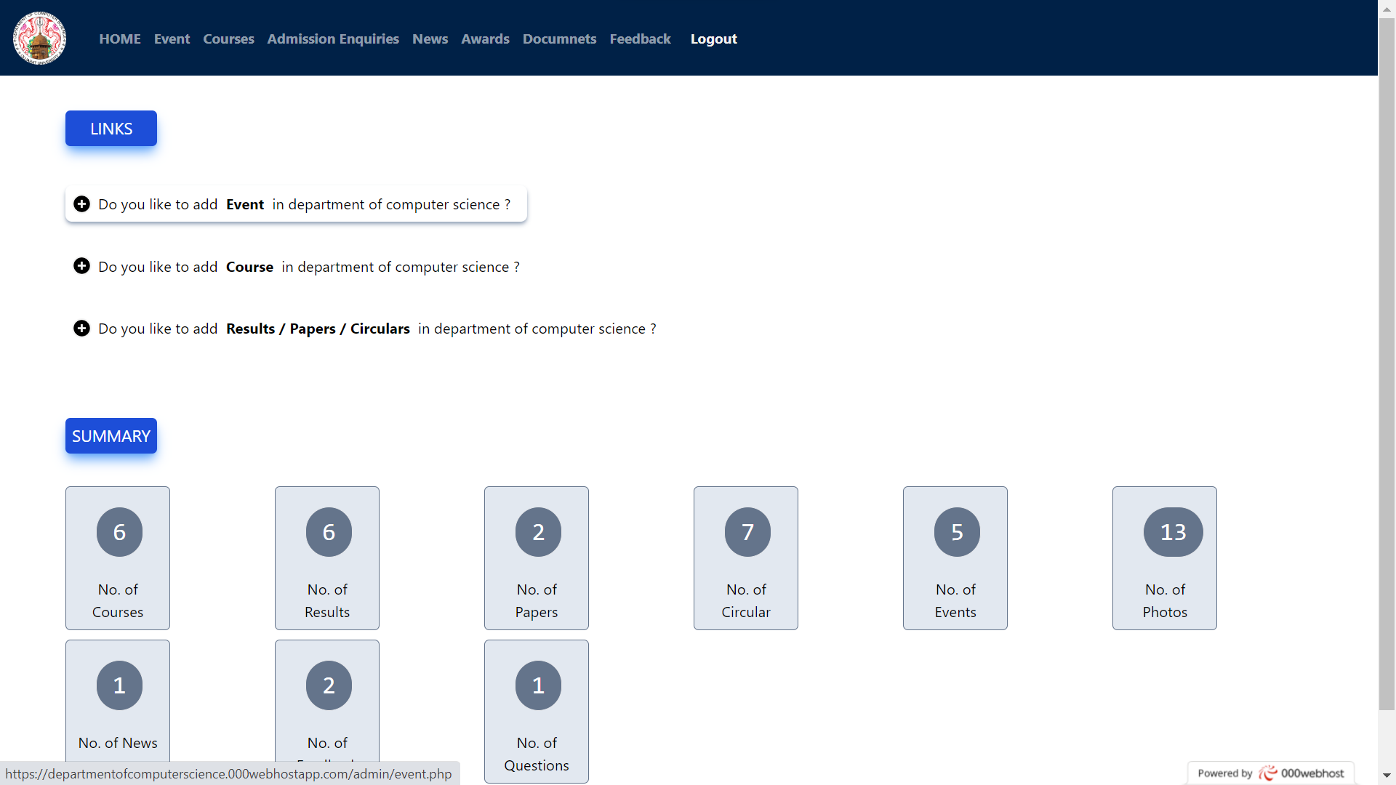

* **ADMIN EVENT PAGE**

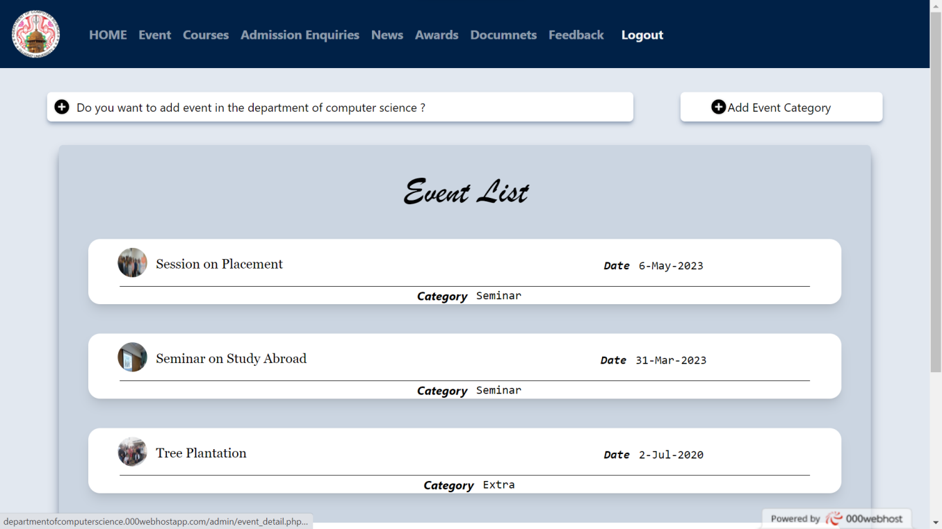

* **ADMIN ADD EVENT**

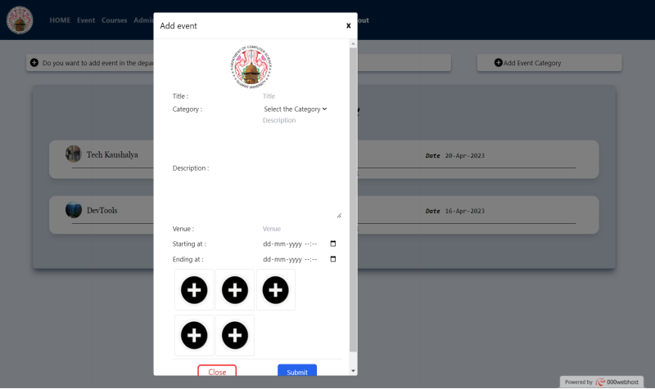

* **ADMIN COURSE PAGE**

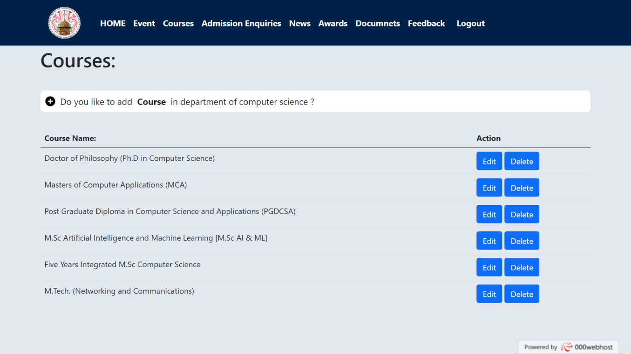

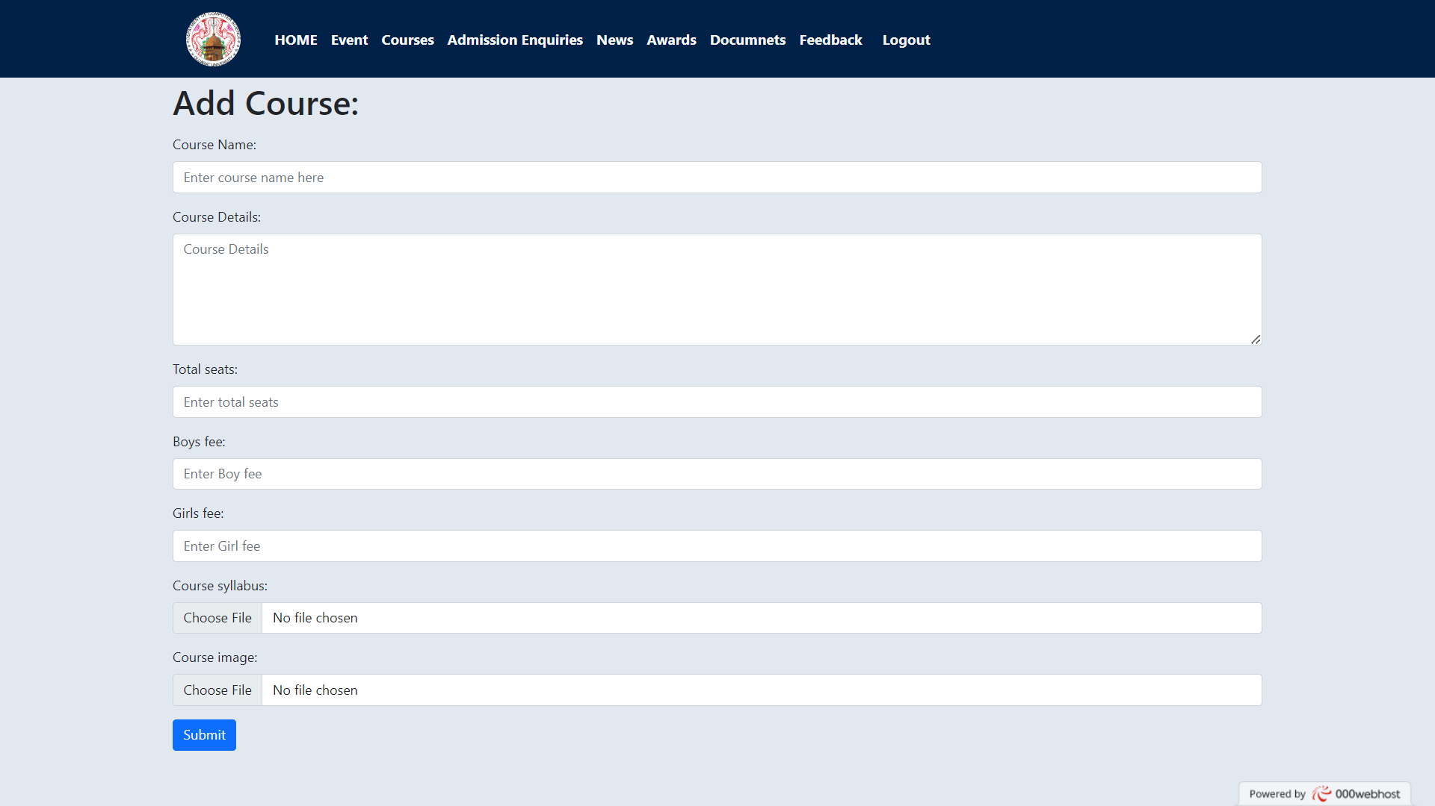

* **ADMIN ENQUIRY PAGE**

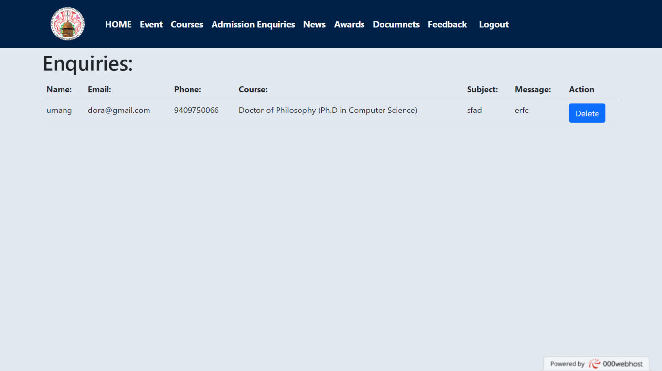

* **ADMIN NEWS PAGE**

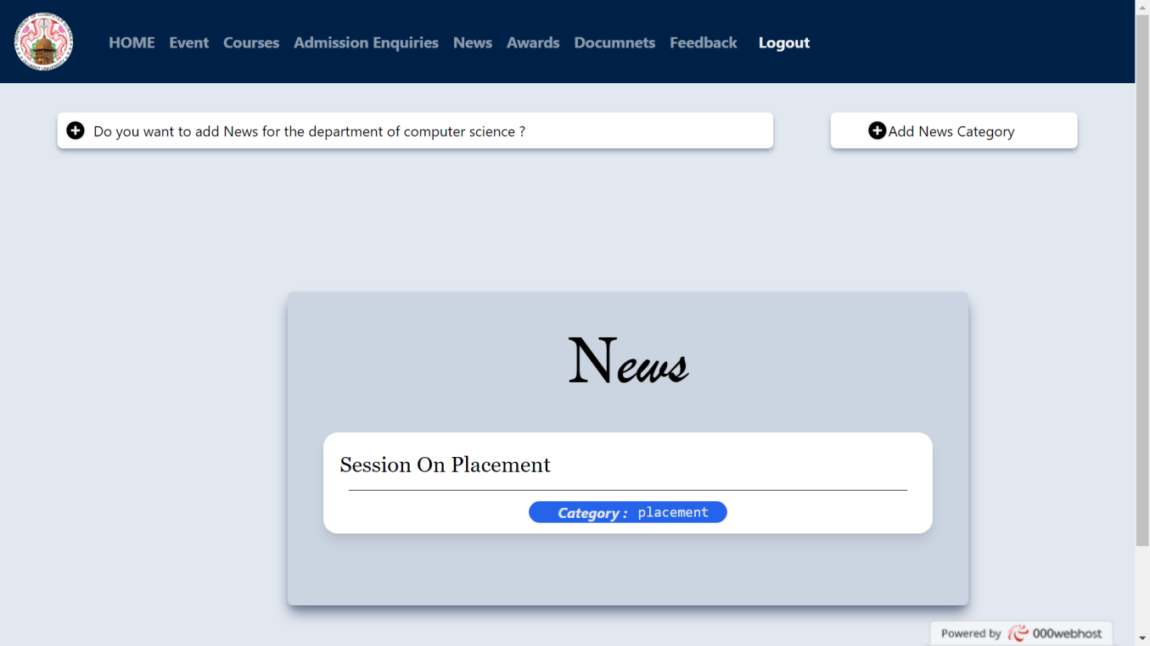

* **ADMIN AWARDS PAGE**

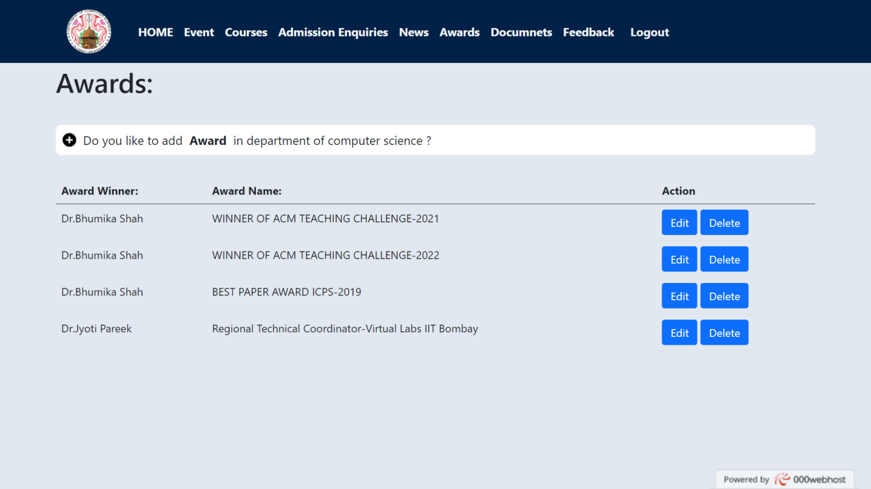

* **ADMIN DOCUMENTS PAGE**

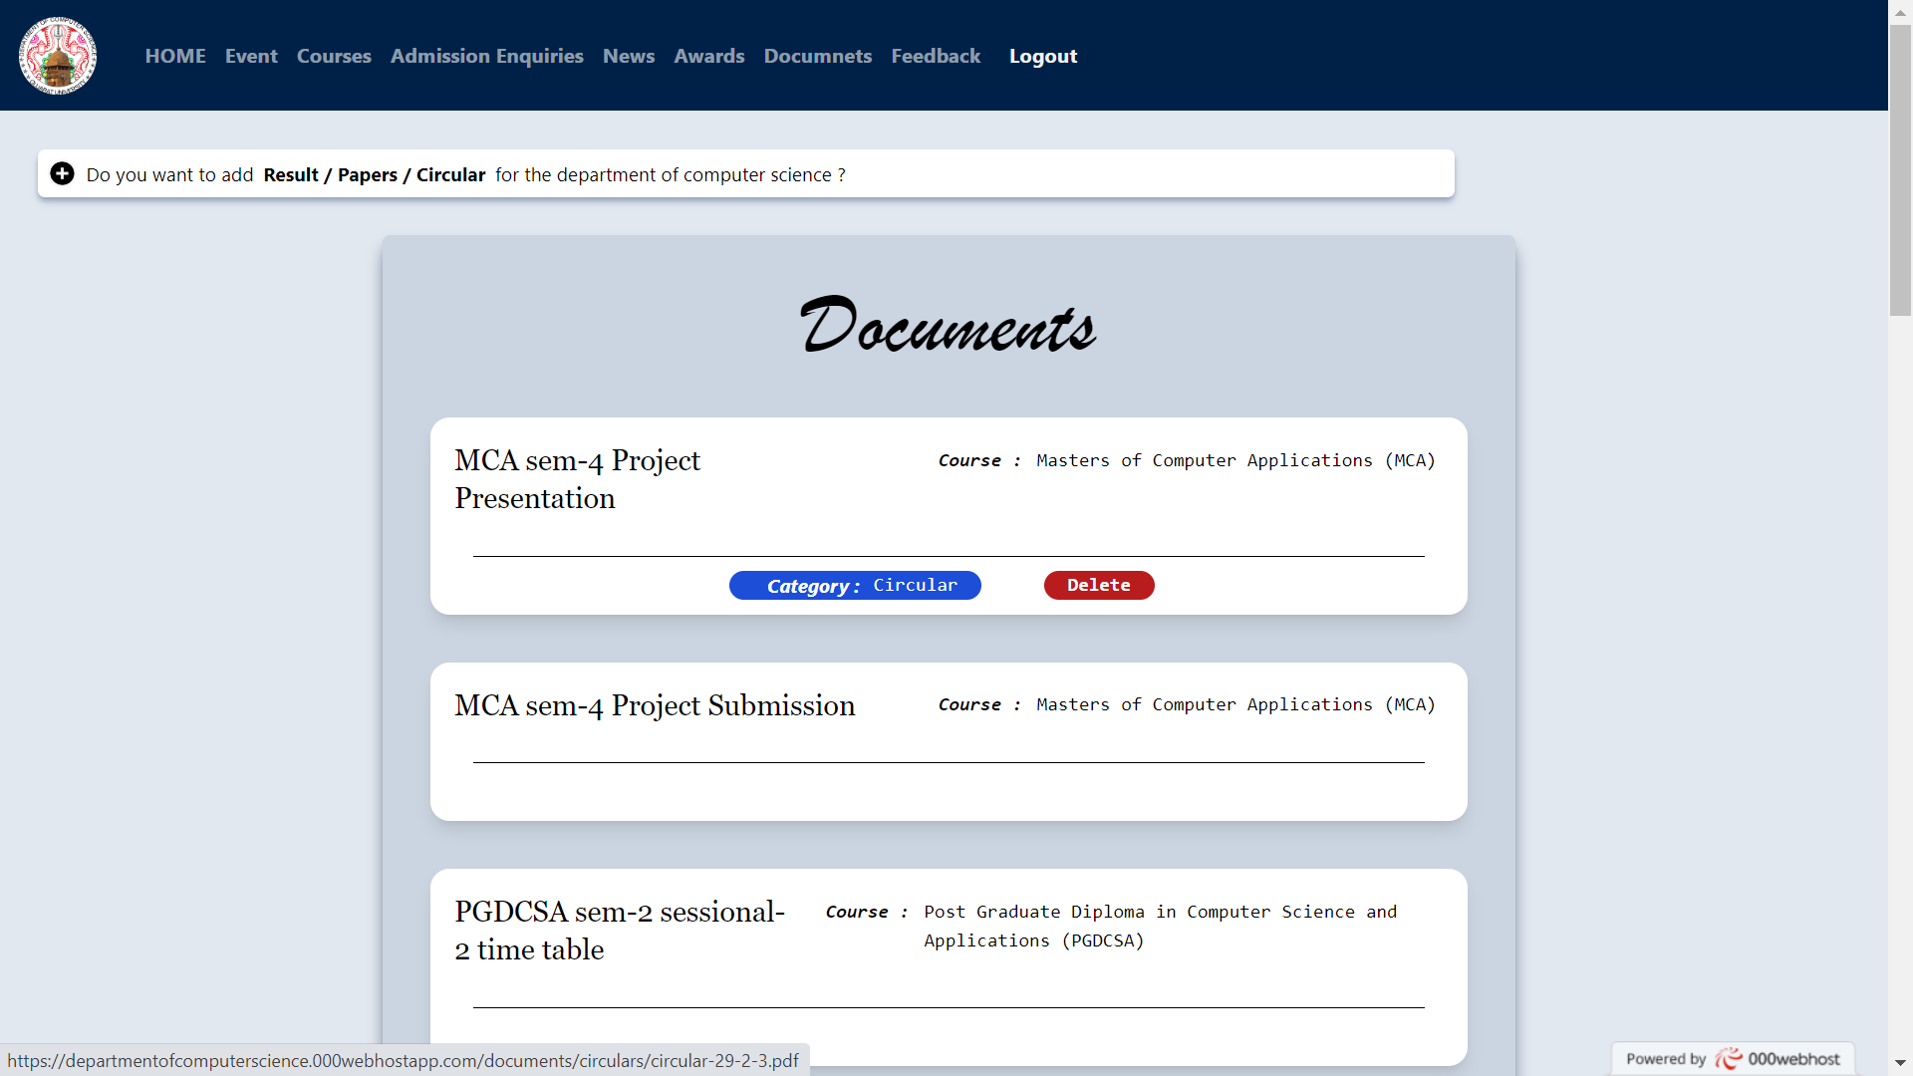

* **ADMIN FEEDBACK PAGE**

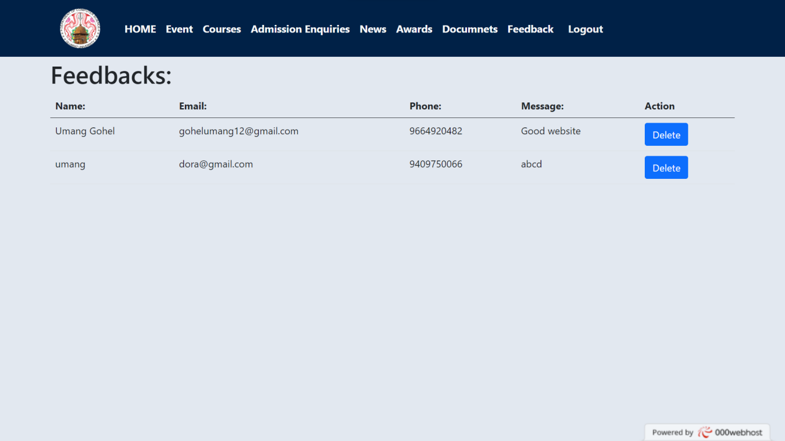

In conclusion, our Department of Computer Science website serves as a comprehensive and user-friendly platform for students, faculty, and the wider community. It provides easy access to essential information such as circulars, Question papers, courses, admission details, syllabi, and results.

We accept your feedback and encourage active participation through our dedicated feedback section. Your input is crucial in helping us improve our services and cater to your needs effectively.

Our interactive chatbot is readily available to provide quick and efficient assistance. Whether you have questions about a specific course or need guidance on academic matters, our chatbot is here to assist you every step of the way.

For those looking to enhance their learning journey, our Epg Pathshala offers a wealth of educational resources. From study materials to online tutorials, you'll find a range of materials to supplement your studies and expand your knowledge.

Stay up to date with the latest news, events, and research outcomes in the department of computer science through our regularly updated website. We aim to keep you informed about advancements, conferences, and other significant developments in the field, ensuring you stay at the forefront of knowledge.

We take immense pride in acknowledging the accomplishments of our students and faculty. Our website showcases the awards and honors earned within our department, highlighting the dedication and excellence demonstrated by our members.

* **CONCLUSION**

At the Department of Computer Science, we are committed to continually improving and expanding our website to meet the evolving needs of our students, faculty, researchers, and the wider community. We have identified several areas for future development and enhancement:

* Course-Specific Resources: We plan to enrich the website withsubject-wise data for each course offered. This includes detailed course descriptions, lecture notes, assignments, and recommended readings. By providing comprehensive resources for each course, we aim to enhance the learning experience and facilitate better understanding of the subject matter.
* Extensive Document Repository: We intend to create a comprehensive document repository that encompasses a wide range of resources, including circulars, research Question papers, conference proceedings, and technical reports. This repository will serve as a valuable reference for students and researchers, fostering a culture of exploration and knowledge dissemination within the department.
* Real-Time Result Updates: We recognize the importance of timely result announcements for our students. In the future, we aim to implement a system that provides real-time result updates, ensuring that students have instant access to their performance data. This will facilitate transparency and help students plan their academic progress effectively.
* Interactive Discussion Forums: We envision incorporating interactive discussion forums where students, faculty, and researchers can engage in meaningful discussions, seek guidance, and share insights related to various computer science topics. These forums will serve as platforms for collaboration, networking, and knowledge exchange, fostering a vibrant community within the department.
* Alumni Portal: We understand the significance of maintaining a strong connection with our alumni. To facilitate ongoing engagement, we plan to develop an alumni portal that allows former students to connect with each other, share their experiences, and contribute back to the department through mentorship programs, guest lectures, or collaborative research initiatives.
* Industry Partnerships and Internship Opportunities: We aim to forge strong partnerships with industry organizations and provide students with valuable internship opportunities. By bridging the gap between academia and industry, we will empower our students with practical skills and real-world experiences, preparing them for successful careers in the field of computer science.

Through these future developments, we aspire to create an even more dynamic, informative, and interactive website for the Department of Computer Science. We remain dedicated to ensuring that our website remains a valuable resource hub that caters to the needs of our stakeholders, fosters innovation, and promotes excellence in computer science education and research.

* **FUTURE WORK**

1. Website of Gujarat University: Visit the official website of Gujarat University for information on academic programs, research initiatives, and departmental resources.URL: [https://www.gujaratuniversity.ac.in/]
2. W3Schools (w3schools.com): Access W3Schools, a widely recognized web development resource, for comprehensive tutorials, references, and examples on HTML, CSS, JavaScript, PHP, and MySQL. URL: [https://www.w3schools.com/]
3. Bootstrap (getbootstrap.com): Visit the official website of Bootstrap to discover an extensive collection of pre-built components, templates, and documentation for creating responsive and mobile-friendly websites. URL: [https://getbootstrap.com/]
4. Tailwind CSS (tailwindcss.com): Explore the official website of Tailwind CSS to learn about the utility-first CSS framework that provides a wide range of pre-built components and utilities for rapid web development. URL: [https://tailwindcss.com/]

Please note that these references provide valuable resources for web development, university information, and CSS frameworks. Make sure to visit these websites for detailed information and utilize them as appropriate during the development process for the Department of Computer Science website.

* **REFERENCES**

**THANK YOU**